Inspecting Sodium Chlorate Cars
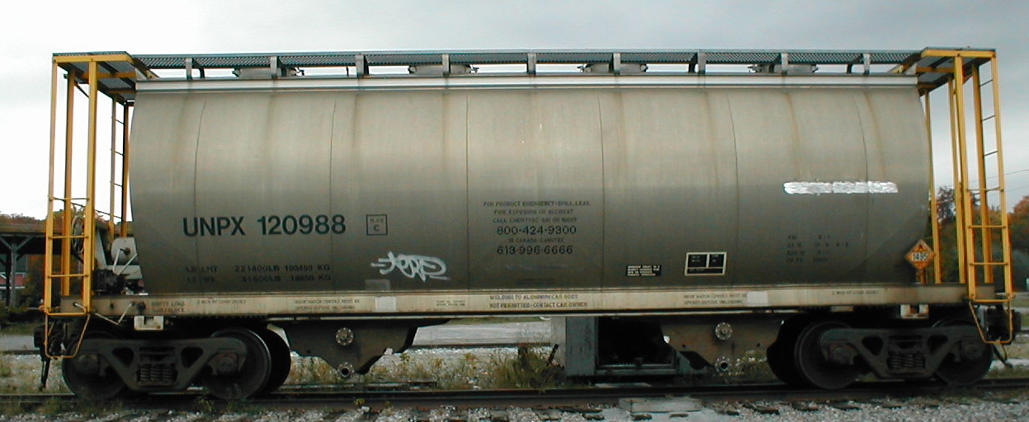
Would you have spotted the problems with this car ?
All hazardous material shipments, whether loaded or containing a residue, must be inspected from ground level for required markings (including stenciling), labels, placards, securement of closures and leakage. Cars may continue in transportation only when the inspection indicates that the cars are in safe condition for transportation and conform to DOT specifications. This car does not meet the requirements.
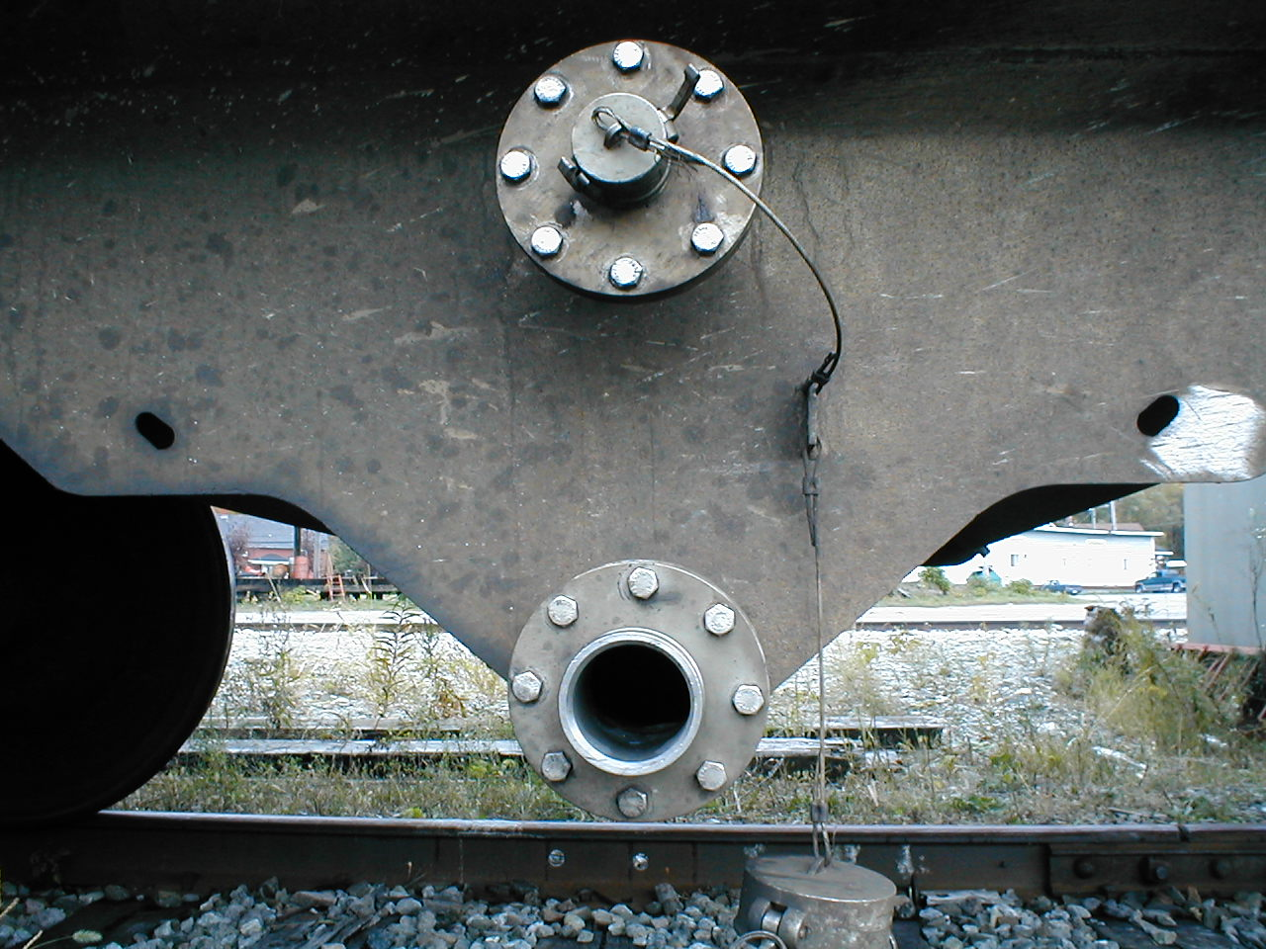 | 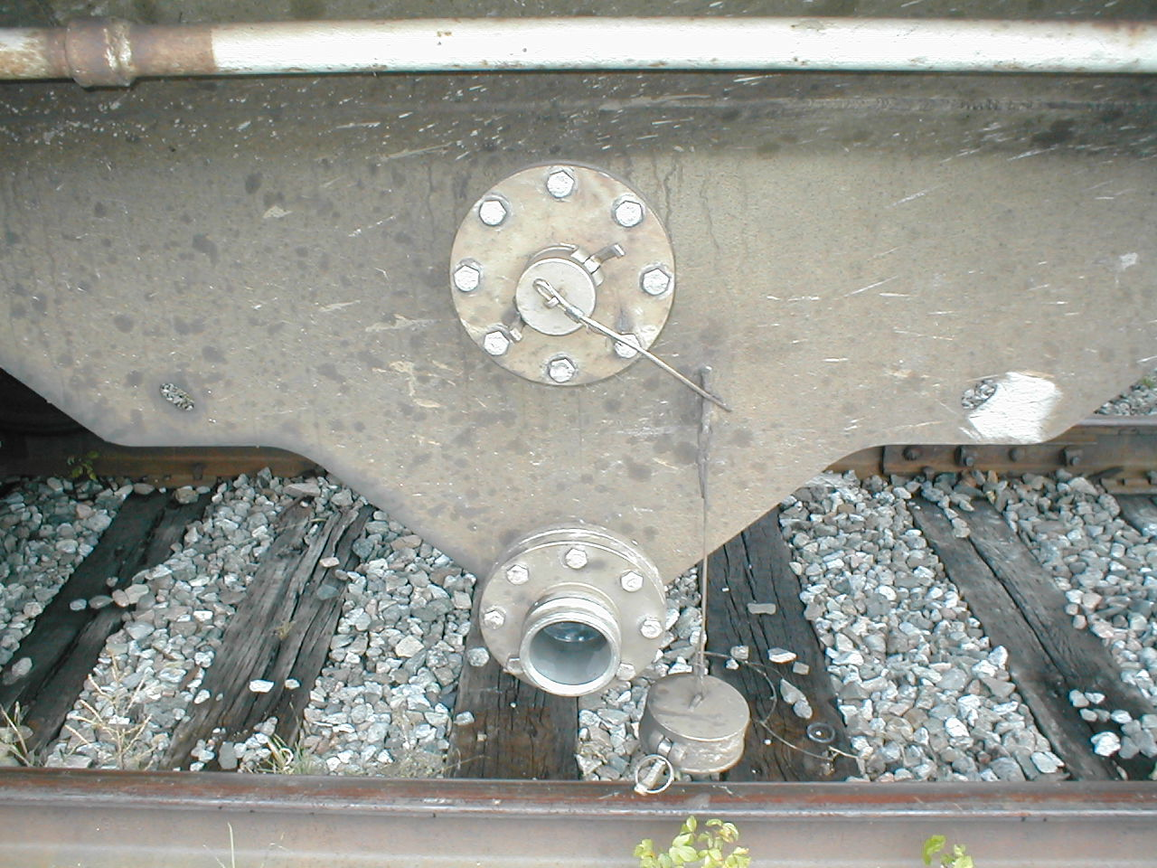 | 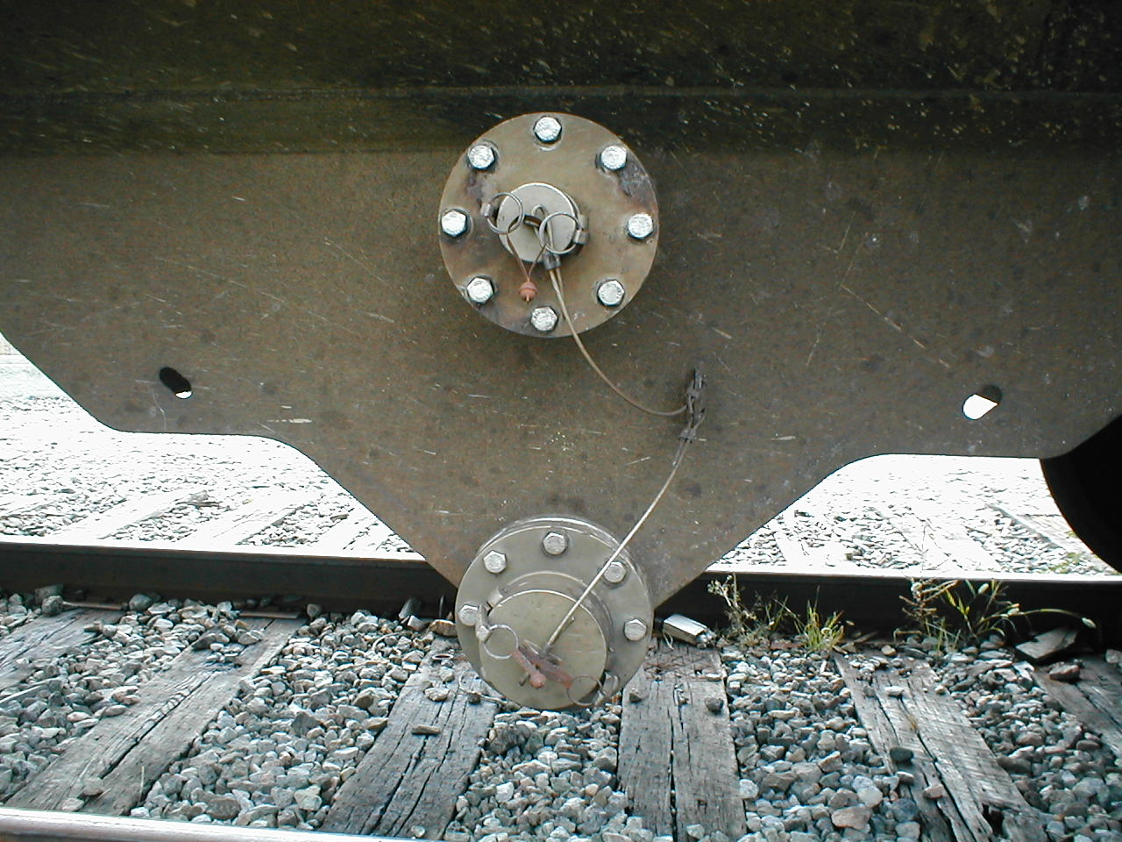
Unsecured outlet cover hanging. | That’s sodium chlorate in the pipe. | This is what the covers should look like.
Make sure you inspect sodium chlorate cars for proper securement of outlet covers before removing them from interchanges or industry tracks.

