One-time Movement Approval Procedures

Hazardous Materials Guidance
Federal Railroad Administration, Office of Railroad Safety, Hazardous Materials Division
1200 New Jersey Avenue SE, Washington, DC 20590
Issue Date: October 7, 2014 | HM Guidance Number: HMG-127
Revision: 4 | 49 CFR Section(s) Affected: 174.50
Page: 1 | Key Words: one-time movement approval (OTMA), leaking, defect, nonconformance, bulk package, bulk packaging, valve, fitting

ONE-TIME MOVEMENT APPROVAL PROCEDURES

Introduction
Since 1996, the Federal Railroad Administration (FRA) has had the authority to issue one-time movement approvals (OTMA) for bulk packages/packaging that no longer conform to the Hazardous Materials Regulations (HMR; Title 49 Code of Federal Regulations (CFR) Parts 171-
180). In 2000, that authority was expanded to cover all bulk packages of hazardous materials (e.g., covered hopper cars, gondola cars, and portable tanks). These changes to the regulations greatly improved the process of gaining approval to move a hazardous material rail shipment that no longer conformed to the HMR. The requests for movement approvals vary from jacket damage that result in a non-weather-tight condition to those with through-shell cracks that result in the release of a hazardous material. As a practical matter, the safety risks associated with the movement of a bulk package/packaging with a small dent in its jacket are significantly different than those associated with a leaking bulk package/packaging loaded with a hazardous material, and those situations must be dealt with differently.
Given the number of requests and the range of possible nonconforming conditions and respective safety risks, FRA has modified the OTMA process. The changes result from reviewing OTMA data, incorporating prior hazardous materials guidance notices, recommendations from a 2011 Peer Review, and comments submitted to Docket Number FRA-2011-0004.
The FRA Hazardous Materials Division (FRA-HM) has an established procedure for evaluating and issuing an OTMA for nonconforming or leaking packages per Title 49 Code of Federal Regulations (CFR) Section 174.50, Nonconforming or leaking packages. The applicant must submit information detailing the nonconforming conditions. The collection of this information is authorized under 49 CFR § 171.6, Control numbers under the paperwork reduction act, and OMB Control Nos. 2137-0557 and 2137-0059. FRA-HM personnel evaluate the information in order to determine whether it is safe to move the bulk package/packaging, and what conditions should apply to the movement. If it can be safely accomplished, the move is authorized by the issuance of a signed FRA OTMA for an OTMA-1 category approval, or an email authorization for an OTMA-2 category approval (applicable only to bulk package shipments that are identified as being overloaded by weight). If the defective condition for a bulk packaging/package falls into an OTMA-3 category approval (referred to as a "standing approval"), then this signed FRA Hazardous Materials Guidance Notice (HMG-127) serves as the authorization for movement.
FRA-HM personnel have evaluated this process over the years and understand the range of defective conditions and their respective frequencies. In addition, there is a growing awareness of the requirement for obtaining an OTMA to move nonconforming bulk packages/packaging, as evidenced by the continually increasing number of requests processed by FRA. A revised process providing greater efficiency without compromising any advances in safety is needed. The OTMA procedures were drafted with the goals of streamlining the process and allowing FRA-HM to monitor nonconformance more productively.
Procedures
This Hazardous Materials Guidance document contains the procedure to be followed by the regulated community to obtain approval to move a noncompliant bulk package. There are three categories of OTMA. The categories are as follows:
- OTMA-1 adheres to the traditional process.
- OTMA-2 requires notification for FRA followed by acknowledgement from FRA in the form of an email authorizing or prohibiting continued movement.
- OTMA-3 is a standing approval.
Each category is described in detail in the following sections. Listed below are general requirements and limitations of the OTMA process.
- Approvals for bulk packaging that are actively leaking will generally not be issued; however, they may be moved "only so far as necessary to reduce or to eliminate an immediate threat or harm to human health or to the environment when it is determined its movement would provide greater safety than allowing the package to remain in place." 49 CFR § 174.50. By submitting a request for OTMA the applicant is certifying the package is not actively leaking and will not leak during transportation as per 49 CFR § 173.24, General requirements for packaging and packages.
- Approval is needed to move nonconforming U.S. Department of Transportation (DOT) specification bulk packaging, or other bulk packaging containing a regulated hazardous material, even if it is secured in or on a rail car. Approval is also needed to move any nonconforming DOT specification bulk packaging even if the DOT specification bulk packaging does not contain a regulated hazardous material as long as the bulk packaging is offered or to be offered and represented in transportation as a DOT specification package (see 49 CFR § 171.2(g)). Approvals will not generally be granted to move tank cars that are overloaded by volume and have insufficient outage in the tank for the products they contain. In these instances, shippers will need to arrange for transloading with the rail carrier in possession of the shipment.
- FRA cannot issue movement approvals for bulk package/packaging that are offered into transportation for interchange service and exceed the age limits prescribed in the Association of American Railroads' (AAR) Interchange Rules, Rule 90. This is not a Federal regulatory age limit, and persons with cars affected by this will need to seek resolution with the Association of American Railroads and the rail carriers involved.
- An approval issued by FRA is only applicable to movements of a defective bulk package/packaging by rail within the United States. Authorized movement of defective bulk package/packaging in Canada requires the issuance of a "temporary certificate" from the appropriate representatives of Transport Canada. The requestor will need to coordinate the request and obtain corresponding approval from Transport Canada for cross-border movement of nonconforming bulk packages/packaging. Movement of defective bulk packages/packaging across the border, to or from Mexico, also requires an applicant to coordinate with the appropriate Mexican agency representatives.
- For the purpose of this document, FRA will assume an empty bulk package contains residue unless a cleaning certificate is provided.
- This document addresses movement approvals of a bulk package/packaging that no longer conforms to the HMR, and provides no relief from any regulation other than as specifically related to the nonconforming condition for which the OTMA was granted. The approval to move a railcar that does not conform to the regulations in Subtitle B of 49 CFR Parts 200-299 must be obtained from FRA's Motive Power and Equipment Division.
- Rail carriers are not obligated to honor an approval issued by FRA, and have the right to refuse movement even if an approval is issued. A rail carrier may require alternate solutions that do not involve further movement on its rail system. FRA strongly urges that the applicant contact appropriate representatives from the rail carriers that will be involved in moving the defective packaging prior to submitting the approval request. This will ensure that the rail carriers are willing and able to conduct transportation of the packaging on their respective systems in order to get the packaging to the requestor's desired location upon issuance of an approval by FRA.
- The requestor is required to maintain information regarding movements, subject to this document, and must make it available upon request to FRA personnel (Paperwork shall be retained per 49 CFR § 172.201, Preparation and retention of shipping papers).
- Failure to comply with the provisions of this document may result in recommendations for enforcement and civil penalties. Furthermore, FRA may issue written notification to any entity found to be noncompliant with the procedure specified in this document requiring that entity to submit all future OTMA requests in accordance with the procedures specified for OTMA-1 regardless of the identified defect. This limitation will apply to the particular entity until otherwise notified by writing by FRA.
- FRA reserves the right to change the contents of this document as conditions require. Additionally, at any point where safety may be compromised, FRA reserves the right not to issue an approval.
OTMA-1 (Traditional)
An OTMA-1 follows the traditional approval process and applies to any non-conforming package/packaging that does not meet the criteria for movement as OTMA-2 or OTMA-3 in this document. All requirements related to the continued movement of the nonconforming rail car or other bulk packaging will be detailed in the signed OTMA, which will be sent to the applicant via fax or email.
Submit the following information with the one-time movement request for the specified noncomplying conditions. This information will permit an evaluation of the defective condition and determination of whether the bulk package/packaging can be moved safely. When photographs are requested, appropriate views should include both an overview of the car, defect, and fittings as well as clear, close up views of the fitting or defect. Also helpful are photographs of the car stenciling, including specification and qualification information. Failure to provide the information below will result in delay in evaluation or denial of your request.
Breaches in tank shell and cracks in the underframe:
- Dimensions, locations, and orientations of cracks.
- Photos or diagrams that provide perspective of location.
- Photos of the breaches and cracks.
- Data (facility, date, and inspection records related to the area with a defect) regarding most recent qualification.
Defective valves and fittings (service equipment) that do not qualify for OTMA-3:
- Photos of fittings arrangement.
- Orientation of fittings arrangement indicating the "A" or "B" ends of the car.
- Make/model of defective fittings.
- Data (facility and date) regarding installation or most recent qualification.
- Location of defect (i.e., at gasket, ball, stem, etc.).
This list identifies the types of information FRA typically requires for processing most OTMA requests. However, some nonconforming conditions may require other types of information not identified in this section. Also, providing accurate and complete information on what actions or measures have been taken, if any, to mitigate the defective condition prior to movement of the bulk packaging will assist the FRA Headquarters Hazardous Materials (HQ HM) Specialist in his or her evaluation of the approval request.
OTMA-2 (Written Notification)
An OTMA-2 applies to railcars found to be overloaded by weight. An applicant must submit written notification to FRA containing information related to the nonconforming condition and shipping papers for the bulk package/packaging. In addition, FRA is requesting the following information be submitted to facilitate processing:
- Scale tickets.
- Loading temperature and specific gravity of commodity at the loading temperature in accordance with 49 CFR 173.24b(a), Additional general requirements for non-bulk packaging and packages.
- Specific gravity of commodity at appropriate reference temperature.
- Capacity (in gallons) and tare weight of bulk package/packaging.
- Innage/outage table for the tank car.
- Any additional information that can be used to demonstrate that the tank car is not overloaded by volume.
After the information is received, evaluated, and approved, the grantee will receive notice, via fax or email, that the review was completed and movement is authorized under this OTMA category. The grantee will be required to ensure that the words, "Moving per 174.50: OTMA-2," are placed on all shipping documentation that is transmitted to each rail carrier involved in the movement of the nonconforming shipment in a location that clearly associates the notation with the basic shipping description. Additionally, a grantee of an OTMA-2 must comply with the General Requirements section of this document unless otherwise exempted through written acknowledgement from FRA. An OTMA-2 will be applicable for bulk package/packaging, or other railcars (e.g., covered hopper cars containing a regulated hazardous material), that are found to be overloaded by greater than 1 percent of the allowable total gross rail load (GRL), rounded up to the next 100 pounds on a weight-in-motion scale; or for any bulk package/packaging that is overloaded by greater than 1,000 pounds of the allowable total GRL on a static scale.
The grantee will have 60 days from the date of FRA's written OTMA-2 approval to move the bulk package to the destination specified in the approval request.
OTMA-3 (Standing Approval)
An OTMA-3 applies to bulk packages/packaging that meet the specific criteria (listed below) for movement as an OTMA-3 may be moved under an OTMA-3 standing approval. A bulk package/packaging involved in a non-accident release may not be moved under an OTMA-3 unless authorized by an FRA HQ HM Specialist. Persons in possession of a nonconforming bulk package/packaging containing PIH (loaded or residue) may not use the provisions of OTMA-3 unless approved to do so by an FRA HQ HM specialist.
A standing approval allows for the movement of the car without response from FRA provided that an accurate and complete OTMA-3 notification (described below) is submitted, in which the defect is one specifically described in listed Defect # Descriptions below and complies with the applicable OTMA-3 and general requirements in this notice.
An OTMA-3 is an approval that will be used for a specific list of nonconforming conditions. Persons in possession of a nonconforming bulk package/packaging will be permitted to use the standing approval provisions of OTMA-3. Prior to offering a nonconforming bulk package/packaging under this category for transportation, an email must be submitted to: HMASSIST@dot.gov to notify FRA of the movement. At a minimum, the subject line of the email must include the notation "OTMA-3/Car Mark and Number/Name of Applicant." The body of the email must contain the following information:
Moving per 49 CFR 174.50 (OTMA-3): Car Number(s):
DOT Specification/ Package Stenciled Specification: Loaded or Residue or Cleaned and Purged: Commodity Name and UN/NA number:
Grantee: Contact Name:
Contact Telephone/Email: (of all personnel knowledgeable about issue):
Defect Number and Description of the Problem:
Present location (Facility/Railroad Name, City, State): Destination (Facility Name, City, State):
Routing:
Bulk package/packaging must be stenciled, decaled or tagged with the following message:
"Home shop for repairs, do not load"; "Moving for dismantling,
do not load"; or other words to convey a similar meaning,
as appropriate.
For all shipping papers transmitted or provided to each rail carrier involved in the movement of the nonconforming shipment, each person implementing this category will be required to include a description of nonconformance and the words, "Moving per 174.50: OTMA-3," along with the identity of the destination facility. Each applicant must also keep a copy of the shipping paper and a description of the nonconformance on file per the requirements of 49 CFR § 172.201. For movements that do not require shipping papers per the HMR, this information is required on shipping documentation transmitted or provided to each rail carrier involved in the movement of the nonconforming bulk package/packaging (e.g., a waybill for the defective package/packaging).
Movement under this standing approval is authorized only for the purpose of moving a bulk package/packaging for cleaning, repair, or dismantling; or continued movement for unloading followed by cleaning, repair, or dismantling, and the car is represented as meeting its DOT specification. A grantee of an OTMA-3 must also satisfy the General Requirements section of this document.
Applicability for movement under an OTMA-3:
- Loaded bulk packages (regulated material only)
- Clean bulk packaging (cleaning certificate required)
- Residue bulk packages (regulated material only)
- Bulk package containing (loaded or residue) a nonregulated material
The nonconforming, circumstances, and/or conditions covered by this category, along with the applicability, are as follows:
OTMA-3 Defect Numbers and Descriptions
Service Equipment-Top Fittings
Defect No. 1 | Following replacement of a valve or fitting, with a nondefective valve or fitting, or closure to prevent the release of material (e.g., replacement of a defective vacuum relief valve with a pipe plug, or a liquid or vapor valve with a blind flange). A pressure relief device may only be replaced in kind. Applicability: A, B, C, D
Defect No.2 | For repair (other than removal of the fitting) performed on a connection that is subject to qualification/requalification. This includes, but is not limited to, replacement of hinged manway cover eye bolts, external "0" rings on safety relief valves, tightening securement fasteners that does not result in damage or deformation of the stud or bolt securing an operating valve stem packing gland nut (other than a top operated bottom outlet). Applicability: A, B, C, D
Defect No.3 | A bulk package/packaging with defective manway cover securement bolts where the number of defective manway cover securement bolts does not prevent achieving an adequate seal of the manway cover that would allow the cars to remain in compliance with 49 CFR § 173.24(b)(1) for the duration of the movement to the destination. Applicability: B, C, D
Defect No.4 | A bulk package/packaging with missing or damaged service equipment parts, provided the service equipment is free from leakage (e.g., missing magnetic gauging device rod, top or bottom valve handles, a quick-inspect port cable, or pipe-plug chain). Applicability: A, B, C, D
Defect No.5 | A bulk package/packaging requiring a leakage pressure test to verify the integrity of the completed repairs. Applicability: B, C, D
Defect No.6 | A clean bulk packaging without damage to the tank. Applicability: B
Defect No.7 | A general-purpose bulk package/packaging (tank car) that has damage to the protective housing. Applicability: A, B, C, D

Service Equipment-Bottom Fittings
Defect No. 8 | Defective bottom outlet valve, provided the material is contained by the application of the secondary closure. This does not include the flanged connection between the valve and tank, or any other damage inboard of the primary valve. Applicability: B, C, D
Defect No.9 | A bulk package/packaging that has the primary bottom discontinuity closure intact, but has incurred damage to the secondary closure portion of the bottom discontinuity and/or bottom discontinuity protection. Applicability: B, C, D
Defect No. 10 | Securing an operating valve stem packing gland nut. Applicability: A, B, C, D

Interior Coating/Lining
Defect No. 11 | A bulk package/packaging with a defective interior lining or coating that has not resulted in damage to the tank (bulk packages/packaging with a defective coating or lining installed for product purity is not subject to these safety measures). Applicability: B, C, D

Heater Coils
Defect No. 12 | A bulk package/packaging with a defective interior heater coil. Applicability: B
Defect No. 13 | A bulk package/packaging with a defective exterior heater coil provided the defect does not introduce a flow path into the product space or otherwise compromise the integrity of the tank. Applicability: A, B, C, D

Jacket/Insulation
Defect No. 14 | A bulk package/packaging that has incurred damage solely to its jacket, such that the jacket is no longer "weather-tight," provided there is no damage to the tank. Applicability: A, B, C, D

Derailment Damage
Defect No. 15 | A bulk package/packaging with damage resulting from a collision or derailment, which is loaded onto or into another rail car conveyance such as a flatcar or gondola car. Applicability: B, C

Marking/Stenciling
Defect No. 16 | A bulk package/packaging with faded, unreadable or missing markings that are required under 49 CFR § 172.330(a)(1)(ii) and § 179.22 (e.g., DOT packaging specification number, proper shipping name, and qualification due dates), provided that the markings are reapplied at the destination that the bulk package/packaging is being moved to. This provision does not apply to identification number markings, inhalation hazard markings, marine pollutant markings, or any other required markings pertaining to the regulated product, except as stated above. Applicability: A, B, C, D

OTMA Flowchart

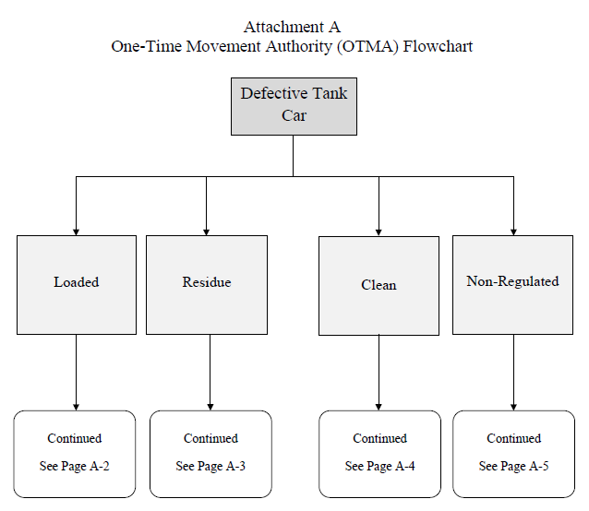

Loaded A-2
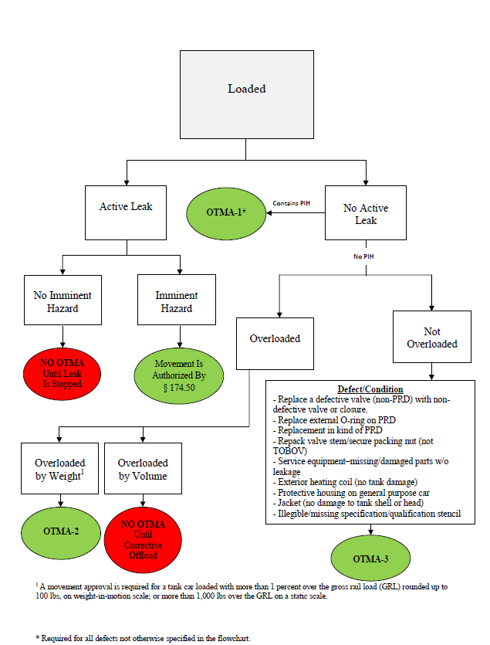

Residue A-3
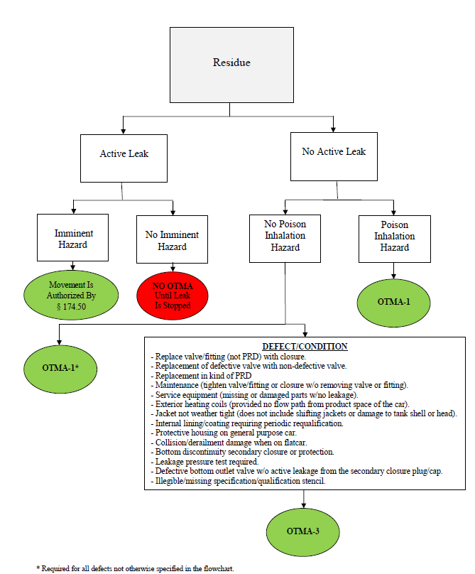

Clean A-4
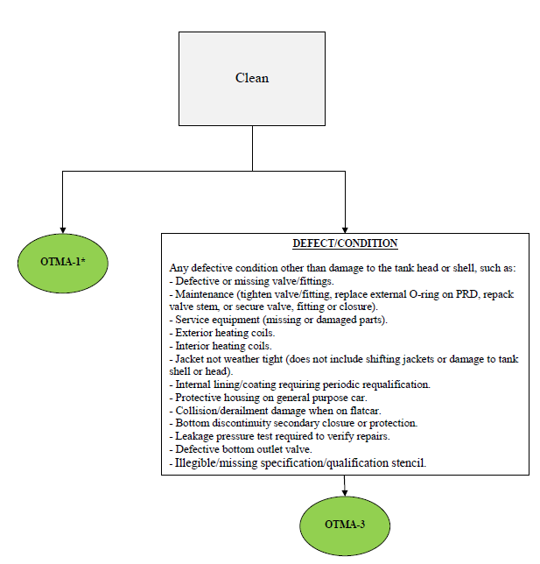

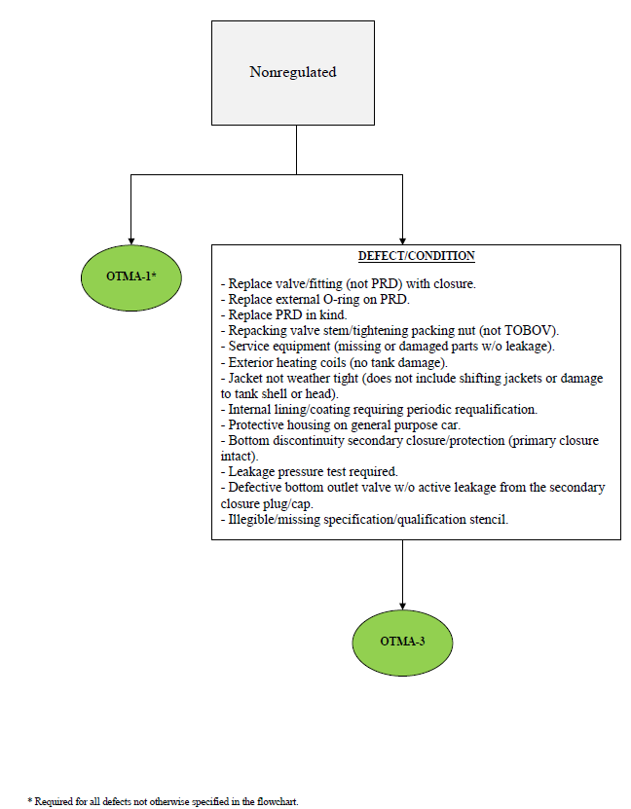
Nonregulated A-5

