Railroad Name
Hazardous Materials and
Oil Spill Prevention
and Emergency Response Plan

ISSUED: Date
Revised: Date

Contents
Contents i
1 Introduction, Purpose, and Definitions 1-1
1.1 Introduction 1-1
1.2 Definitions 1-2
2 Emergency Notifications and Contacts 2-1
2.1 State and Local Notification Requirements 2-1
2.2 Shipper Notification Requirements 2-1
2.3 Federal Notification Requirements 2-2
2.4 Notifications for Any Petroleum Release to Surface Water 2-2
2.5 Other Shared Rail Notifications and Contacts 2-2
2.6 Railroad Name Notifications and Contacts 2-3
2.7 Emergency Response Contractors and Consultants 2-3
2.8 Other Support Personnel 2-4
3 Incident/Accident Notification Worksheet 3-1
4 Mapping & Critical Receptors 4-1
4.1 System Map 4-1
4.2 Critical Receptors 4-2
5 Oil Containment and Protective Boom Procedures 5-1
5.1 Oil Spill Response Priorities 5-1
5.2 Resource Strategies 5-3
5.3 Critical Containment & Clean Up Factors 5-6
5.4 Containment & Recovery Support 5-7
5.5 Figures 5-7
6 Incident Management 6-1
6.1 On-Scene Command 6-1
6.2 Guidelines for Determining Incident Levels 6-2
6.3 Level I Incidents 6-2
6.4 Level II Incidents 6-3
6.5 Level III Incidents 6-3
6.6 Initial Notification Procedures 6-4
6.7 Responsibilities 6-5
6.8 Emergency Response Contractors 6-5
6.9 Guidelines for Determining Incident Level and Response 6-7
7 One-time Movement Approval Procedures 7-1
7.1 OTMA Flowchart 7-9
7.2 Loaded A-2 7-10
7.3 Residue A-3 7-11
7.4 Clean A-4 7-12
7.5 Nonregulated A-5 7-13
8 OSRO Registrations and Classifications 8-1
8.1 OSRO Listed Organizations (9-2018) 8-2

Introduction, Purpose, and Definitions
The purpose of this document is to identify actions taken in preparation for and in response to a potential release of oil or hazardous substances from a transportation event on Railroad Name.

The Emergency Response Plan has been developed and implemented in accordance with 49 Code of Federal Regulations, Part 130 to meet the requirements of an Oil Spill Prevention and Response Plan as outlined within these regulations, in conjunction with Railroad Name Emergency Response Plan, the National Contingency Plan (NCP - 40 CFR 300), the Area Contingency Plans for the Railroad Name Areas, and the Oil Pollution Act of 1990.

Introduction
As demonstrated in the following sections, Railroad Name has developed adequate systems, procedures and plans, field tested by our team, to manage any incident along our planned route. In response to a known or suspected release of oil on our system we will rapidly notify responders and governmental agencies, as required, for an appropriate response. In the event of an emergency, we will mobilize all resources necessary to safely, effectively and efficiently provide appropriate measures for the protection of our personnel, the community, and the environment. We will report, contain, control, remediate and restore our system to normal operations as outlined in our company policies and procedures.

Providing an appropriate response includes the involvement of local, state and federal agencies as well as internal support personnel and highly trained contractors and consultants experienced in rail incidents. The roles of specialty contractors, consultants and support personnel are described in Section 1.2. Specific companies and individuals supporting our efforts are identified in Sections 2.5, 2.6, and 2.7, along with listed notifications required for incidents. Forms to document initial response actions, notifications and mobilizations are provided in Section 3.

In addition to the companies and individuals listed below to provide specific roles in emergency response to an incident, there are numerous others established in supporting roles. Within our organization some of these roles are provided by internal resources and some provided by external contractors. These groups include roles in assisting the community through managing claims, community support and care programs, and police support. These companies provide additional support to the incident response in filling environmental management, hazardous materials, and industrial hygiene and exposure monitoring roles. Our representatives will activate these groups, as needed, during the course of a potential incident.

During an incident involving oil, there may be a potential for risk to specific areas, homes, businesses, institutions, or bodies of water based on their proximity to the event or a higher level of sensitivity to exposure to the material. We will work in coordination with the incident commander and the local Office of Emergency Management or other designated sources to identify potential sensitive receptors that may be affected by an incident along the route. These locations will be identified for additional protective measures, increased monitoring and awareness in a potential incident and may be used in decisions regarding shelter or short-term evacuations.
In the event of an incident on Railroad Name, an Incident Command Team will be established, consisting of on-scene operating departments. It may become necessary to implement resources beyond our local team’s abilities. Our on-scene management may determine that the incident’s complexities may require or will, by virtue of the type of incident, move into an operation potentially or actually managed under federal, state, local and company management, within a unified command process. If this determination is reached the procedures outlined in Sections 6 and 7 will be applied. We will rely on the agencies presented in Section 2 in coordination the incident commander to identify potential sensitive receptors that may be affected.

Introductory information on oil will include that the material is widely variable in physical characteristics and chemical composition. A generic description and list of properties would be misleading based on these variables. Accordingly, a product-specific Material Safety Data Sheet, provided by the shipper, will be obtained as soon as possible in the event of an incident.

Definitions
Individuals and companies identified in the emergency contacts in Section 2.6 have specific roles in response to incidents. We will mobilize some or all of these specialty skill sets and specific equipment in sufficient quantity to appropriately manage an incident, based on the best-available information at the time.

Hazardous Materials Contractors − Responsible for immediate response assessment of damaged tank cars and management of tank cars, product recovery, transfers, fire support, and other tasks as assigned. These contractors mobilize specialty equipment, vacuum trucks, pumps, boats, meters and trucks for management of dangerous materials.

Environmental Contractors − Responsible for immediate response and containment and recovery of releases with impacted soil and water including segregation and accumulation of waste materials, and overall site remediation. These contractors mobilize equipment, boats, vacuum trucks, and other materials for mitigation of releases.

Environmental Consultants – Responsible for providing environmental monitoring of any soil and water impacts and environmentally sensitive receptors. They assist in preparation of assessment and remedial actions, development of environmental work plans, documentation, and proper management of waste materials. These consultants are active in post-incident remediation, if necessary, and regulatory agency communication.

Derailment, Re-railing and Track Repair Contractors − These contractors are responsible for the safe movement and staging of damaged track and railcars, re-grading railroad property and replacement or repair of damaged tracks.

Air Monitoring Contractors − Have capacity, depending of the situation, to deploy toxicologists, industrial hygienists, and air monitoring professionals based on the level of severity of the incident. These teams evaluate and document potential community and worker exposures and evaluate air issues associated with evacuation limits and actions related to workers and sensitive receptors.

Tank Car Specialists − Highly trained individuals are on call to support an incident with management of particularly sensitive damaged tank cars from an incident. Specialists conduct tank car damage assessment.

Aquatic Toxicology and Biology Consultants – Responsible for aquatic biology and wetlands issues. Coordination and permitting for work in wetlands and management of issues with threatened or endangered species in wetlands and surface water bodies.

NIMS and ICS Specialists − Responsible for facilitating work under the National Incident Management System (NIMS) and the Incident Command System (ICS).

Miscellaneous Suppliers − Additional resources may be needed for specific larger scale incidents. While other initial contractors should have resources and contacts for these items it is helpful to identify sufficient the resources items that maybe required in advance to include:
- Sources for firefighting foam and foam trailers (often available through a Class I partner)
- Sources of additional frac tanks and roll-off boxes for impacted water and soil storage
- Sources of specialty items like excavating equipment and long-reach track hoes
- Sources for drone flight photography
- Suppliers for food, sanitary and comfort stations, warming tents, shower, trailers, etc.

Emergency Notifications and Contacts
In the event of an incident involving rail transport of oil and hazardous materials, use the Incident/Accident Notification Worksheet and guidelines provided in Section 3 to make and record notifications to 911 operators, agencies, and Railroad Name support contacts below, as appropriate.

State and Local Notification Requirements
(List Agencies and notification contacts for your operations areas along with release quantities for oil reporting, See Regulatory Reporting Section and your local reporting requirements.)
Agency | Contact Information | Requirement
Insert name of all requiring Agencies (State Env., LEPC, County, City, Tribal, etc.) for your operating area. | Insert Contact #s/ names | Insert issues requiring reporting e.g. all releases, specific quantities, conditions, etc.)

Shipper Notification Requirements
Organization | Contact Information | Requirement
CHEMTREC | 800-424-9300 (24 hours) | Notification required unless alternate 24-hour response number provided by shipper
Add other company-specific notification contact information that does not utilize CHEMTREC

Federal Notification Requirements
Agency | Contact Information | Requirement
National Response Center | 800-424-8802 (24 hours) | Release of petroleum products into waterway or hazardous materials exceeding the reportable quantity (RQ)
US Fish & Wildlife Service via Department of Interior – (SPECIFIC REGION) | Regional Office Contact Number | Any release of pollutants or contaminants that could impact habitats
US Environmental Protection Agency (SPECIFIC REGION) | Regional Office Contact Number | Contact number to provide progress reports after initial NRC notification

Notifications for Any Petroleum Release to Surface Water
Agency | Contact Information | Requirement
National Response Center | 800-424-8802 (24 hours) | Release of petroleum products
US Fish & Wildlife Service via Department of Interior - (SPECIFIC REGION) | Regional office contact number | Any release of pollutants or contaminants that could impact habitats
US Army Corps of Engineers,  (List District Office) | Regional office contacts | Releases to surface water and/or requiring disturbing wetlands
List State Agency | Agency contact information | Any environmental release of pollutants or contaminants

Other Shared Rail Notifications and Contacts

(List connecting railroads or groups for notification)
Company | Contact Information | Requirement
Union Pacific | 888-877-7267 or 800-892-1283
CSX Transportation | 800-232-1044
AMTRAK | 800-331-0008
BNSF | 800-832-5452
Canadian Nation | 800-465-9239
Canadian Pacific | 800-716-9132
Conrail | 800-272-0911
Kansas City Southern | 877-527-9464
Norfolk Southern | 800-453-2530
List Others

Railroad Name Notifications and Contacts
Name | Contact Information | Office No. | Mobile No. | Notice Required
(List internal railroad contacts critical to your response by title and name)

Emergency Response Contractors and Consultants
(List consultants and contractors to support railroad response, and their duties)
Contractor Name | Contact Information | OSRO Number | HazMat Response | Petroleum Remediation | Duties

Other Support Personnel
Name | Title | Office No. | Mobile No. | Home No.

Incident/Accident Notification Worksheet

Date: |  |  |  |  |  |  |  |  |  |  |  |  |  |  |  |  |  |  |  |  |  |  |  |  |  |  | Train Symbol:
Time: |  |  |  |  |  |  |  |  |  |  |  |  |  |  |  |  |  |  |  |  |  |  |  |  |  |  | Location:
Track/MP or Yard Name: |  |  |  |  |  |  |  |  |  |  |  |  |  |  |  |  |  |  |  |  |  |  |  |  |  |  | Weather:
Municipality |  |  |  |  |  |  |  |  |  |  |  |  |  |  |  |  |  |  |  |  |  |  |  |  |  |  | County:
Type of Accident: |  |  |  |  |  |  |  | Derailment |  |  |  |  |  |  |  |  |  |  |  | Crossing |  |  |  |  |  |  | Trespasser |  |  |  |  |  |  |  | At Grade Crossing
 |  |  |  |  |  |  |  | Street:
Fatalities |  |  |  |  |  |  |  |  |  |  |  |  |  |  |  |  |  |  |  |  |  |  |  |  |  | Injuries
Total Number of fatalities |  |  |  |  |  |  |  |  |  |  |  |  |  |  |  |  |  |  |  |  |  |  |  |  |  | Total number of injured
Number in vehicles |  |  |  |  |  |  |  |  |  |  |  |  |  |  |  |  |  |  |  |  |  |  |  |  |  | Number in vehicles
Number pedestrian fatalities |  |  |  |  |  |  |  |  |  |  |  |  |  |  |  |  |  |  |  |  |  |  |  |  |  | Number pedestrians injured
Number employee fatalities |  |  |  |  |  |  |  |  |  |  |  |  |  |  |  |  |  |  |  |  |  |  |  |  |  | Number employee injuries
Property Damage:
Passenger train involved: |  |  |  |  |  |  |  |  |  |  |  |  |  |  |  |  | Yes |  |  |  |  |  |  |  |  |  | No
Engineer: |  |  |  |  |  |  |  |  |  |  |  |  |  |  |  |  |  |  |  |  |  |  |  | Conductor:
Brakeman: |  |  |  |  |  |  |  |  |  |  |  |  |  |  |  |  |  |  |  |  |  |  |  | Other:
Consist: | Locomotives
 | Loads |  |  |  |  |  |  |  |  |  |  |  |  |  |  |  |  |  |  |  |  | Empties |  |  |  |  |  |  |  |  |  |  |  |  |  |  | Tons
Injuries: |  |  |  |  |  |  | Yes |  |  |  |  |  |  |  |  | No |  |  |  |  |  | Main Line Blocked? |  |  |  |  |  |  |  |  |  |  |  |  |  |  | Yes |  |  |  |  | No
HazMat Involved? |  |  |  |  |  |  | Yes |  |  |  |  |  |  |  | No |  |  |  |  |  |  | If so, leaking? |  |  |  |  |  |  |  |  |  |  |  |  |  |  | Yes |  |  |  |  | No
Local Fire Dept? |  |  |  |  |  |  | Yes |  |  |  |  |  |  |  | No |  |  |  |  |  |  | Local Police Dept? |  |  |  |  |  |  |  |  |  |  |  |  |  |  | Yes |  |  |  |  | No
Ambulance? |  |  |  |  |  |  | Yes |  |  |  |  |  |  |  | No |  |  |  |  |  |  | Railroad Police? |  |  |  |  |  |  |  |  |  |  |  |  |  |  | Yes |  |  |  |  | No
Evacuation? |  |  |  |  |  |  | Yes |  |  |  |  |  |  |  | No |  |  |  |  |  |  | Estimated Area
Record the following additional items with reporting to NRC and EPA/ State, etc.

Source and cause of the release or spill (to extent known) ______________________________________________
Types of material(s) released or spilled ____________________________________________________________
Quantity of materials released or spilled, if known (update after assessment) _______________________________
Medium (e.g. land, water) affected by release or spill (add name of water body if known) ____________________
Danger or threat posed by the release or spill and any other information that may help emergency personnel respond to the incident _________________________________________________________________________
Precautions taken _____________________________________________________________________________

Notifications (Internal) (List key internal names, 24 hr. phone and when contacted)
______________ _______________ _________
Person & Title Phone Time
_______________ _______________ _________
Person & Title Phone Time
_______________ _______________ _________
Person & Title Phone Time
_______________ _______________ _________
Person & Title Phone Time

HAZMAT Emergency Response Contact
(designated on the train consist or waybill)

CHEMTREC 1-800-424-9300
 |  | Person |  |  | Case/Ref # |  |  |  | Time
Other
 | Group/Phone Number | Person |  |  | Case/Ref # |  |  |  | Time
National Response Center
1-800-424-8802 |  | Person |  |  | Case/Ref # |  |  |  | Time
National Transportation Safety Board
202-314-6290 |  | Person |  |  | Case/Ref # |  |  |  | Time
State / Federal Agencies
(Insert state agency and phone)
 |  | Person |  |  | Case/Ref # |  |  |  | Time
U.S. Fish and Wildlife Service (notify in the event a release could affect wildlife habitat or wetlands)
(Insert Regional Phone)
 |  | Person |  |  | Case/Ref # |  |  |  | Time
USACE (Regional office notice for wetland permit)
(Insert District Phone) |  | Person |  |  | Case/Ref # |  |  |  | Time
Notes:
Local Office of Emergency Management (OEM), Local Emergency Planning Committee (LEPC) or Emergency Management Agency (EMA)
List OEM, LEPC or EMA Contacts
 |  | Person & Title |  |  | Case/Ref # |  |  |  | Time
 |  | Person & Title |  |  | Case/Ref # |  |  |  | Time
 |  | Person & Title |  |  | Case/Ref # |  |  |  | Time
 |  | Person & Title |  |  | Case/Ref # |  |  |  | Time
 |  | Person & Title |  |  | Case/Ref # |  |  |  | Time
Notifications (External)
Personal Injury/Property Damage/ Claims (List key contacts and note when contacted)

___________________ _______________ _________
Person & Title Phone Time

___________________ _______________ _________
Person & Title Phone Time

___________________ _______________ _________
Person & Title Phone Time

___________________ _______________ _________
Person & Title Phone Time

Other Rail Notifications and Contacts/Contractors

________________________
Organization/ Phone |  |  | Person |  |  |  |  | Case/Ref # |  |  |  | Time
________________________
Organization/Phone |  |  | Person |  |  |  |  | Case/Ref # |  |  |  | Time
________________________
Organization/Phone |  |  | Person |  |  |  |  | Case/Ref # |  |  |  | Time
Notes:

Private Rerailing, Response and Transfer Contractors
Rerailing Contractors (List here) (Examples)
 | TERRA | 1-800-298-3772
 |  |  |  |  |  | Time |  |  |  | ETA
 | HULCHER | 1-800-637-5471
 |  |  |  |  |  | Time |  |  |  | ETA
 | R.J. CORMAN | 1-800-772-9091
 | (Other)_____________ | _______________ |  |  |  | Time |  |  |  | ETA
 |  |  |  |  |  | Time |  |  |  | ETA
Specialty Response Contractors and Consultants (List contacts and 24-hour phone)

Name/Title/Company/Role |  |  |  |  |  | Time |  |  |  | ETA
Name/Title/Company/Role |  |  |  |  |  | Time |  |  |  | ETA
Name/Title/Company/Role |  |  |  |  |  | Time |  |  |  | ETA
Name/Title/Company/Role |  |  |  |  |  | Time |  |  |  | ETA
Name/Title/Company/Role |  |  |  |  |  | Time |  |  |  | ETA
Name/Title/Company/Role |  |  |  |  |  | Time |  |  |  | ETA
Name/Title/Company/Role |  |  |  |  |  | Time |  |  |  | ETA

Notes:

Local and Railroad Name Notification Procedures
Railroad Name
Notifies appropriate personnel, emergency response agencies, and state and federal authorities
Train Incident

Emergency Response Agency
- Manages incident
- Coordinates with media
- Provides fire, EMS and law enforcement support
Train Crew
Remains at the scene until emergency response agency arrives. Provides train consist and locations of hazardous materials
Train Crew
Safely assesses scene and notifies train dispatcher
Railroad Name Emergency Management Team
- Makes internal notifications
- Manages the incident for Railroad Name, activates response resources, as needed
- Coordinates on-scene response

Mapping & Critical Receptors

System Map
(Insert map(s) of your lines, show waterways, and address any critical receptors)

Critical Receptors
Railroad Name will work in coordination with the incident commander and the local Office of Emergency Management or other designated sources (Section 2) that will identify and provide information on potential sensitive receptors that may be affected by an incident along the route.

Oil Containment and Protective Boom Procedures
The equipment and number of personnel needed to support a response to a petroleum oil incident is dependent on numerous factors, including the number of tank cars involved, the amount and type of oil spilled, and the area threatened and/or affected. Understanding of the area in which Railroad Name operates is one critical factor.

Railroad Name has, under contract or other agreements, various types of highly skilled spill response contractors including, but not limited to Coast Guard Classified Oil Spill Removal Organizations (OSROs). These approved contractors and OSROs meet various timing and deployment requirements as outlined within the Coast Guard OSRO Program for deployment and have all equipment necessary for the various levels of OSRO classifications. This organization also has under contract or other approved means additional spill response resources, environmental consultants and subject matter or technical experts with resources available.

Oil Spill Response Priorities
- Safety: Safety is always number one. Protect human health and welfare. This includes, but is not limited to, employee, responder and public safety.
- Containment: Contain the release.
- Protection: Protect environmentally sensitive areas, habitats, wetlands, wildlife area and waterways.
- Clean Up: Clean up all impacted areas safely, efficiently and effectively using whatever approved methods are available.
- Remediate the Effects of the Release: Conduct environmental remediation as approved by federal, state and local experts and regulators.

Containment
Oil containment booms are temporary floating barriers composed of plastic, fabric and other buoyant materials. These booms may be held in place with drift anchors, line and various other methods along their length to ensure that they do not accidently float away, break, or sink. Booms are typically deployed as close as possible to the site of a release affecting or potentially affecting surface water. In locations with tidal influence booms can be deployed upstream and downstream of the release location. We additionally plan for supplemental containment booming downstream of a release point to include deployment near the confluence of the flow with larger downstream water bodies. In areas covered by this plan this is typically at the individual stream’s confluence with the larger body of water. Booms may be placed one half to one mile upstream of the confluence for precautionary measures as dictated by parameters specific to the waterbody, including geometry, flow, and traffic. Booms may need to be moved regularly depending upon flow or tidal influence of the waterbody. Locations of water intakes provided by regulatory authorities, responders or local emergency management groups will be protected to the extent possible.

Type of Booms
Booms: | Absorbent and hard containment booms
Boom Components: | Connectors (universal and cables), shackles, anchors, connector pins, line/rope
Types of Booms: | Fence (No chain for ballast tension, rigid, sheltered area use only)
 | Curtain (Flexible, ballast skirt, good response in waves)
 | Inflatable (Chained tension, heavy duty fabric, good for cascading)

Containment Booms
The typical types of containment booms (curtain booms) used in marshes, creeks, and river environments will be dependent on the depth of water, tidal fluctuation and currents. Standard containment booms for the identified rivers and surrounding tributaries, marshes and creeks fall into the following categories.

Overall  Height | Float  Freeboard | Skirt  Draft | Top  Cable | Ballast  Chain | Weight  Per 100 FT | Volume  Per 100 FT cu ft | Buoyancy  Ratio | Tensile  Strength  lbs. | Sea  Code
6 | 2 | 4 | - | 3/16 | 59 | 7 | 2.2 | 3200 | C
10 | 2 | 4 | - | 1/4 | 110 | 30 | 4.3 | 5000 | C
18 | 6 | 12 | - | 1/4 | 144 | 35 | 7.3 | 5000 | CP
18 | 6 | 12 | 5/16 | 1/4 | 165 | 35 | 6.2 | 15000 | CP
18 | 6 | 12 | 5/16 | 5/16 | 198 | 35 | 5.3 | 17500 | CP

Containment Boom Selection Factors
Type of waterbody: | Marsh, creeks, rivers, offshore, harbors, inlets, bays, channels, natural collection areas, tidal influences, fresh, salt or combination
Environment: | Weather, tides, currents, sea state
Structures: | Pilings, bridges, sea walls, docks, piers
Accessibility: | Type of shoreline, depth of water, marshes, sensitive areas, trees, road access, launch access, rocks, high banks, wildlife habitats
Safety: | Weather conditions, heat and cold factors, personnel, training, qualifications

Containment Boom Configurations
- Protection: This configuration is basic and is installed a short distance away from or off the area being protected. Normally this is a simple barrier configuration to protect a specific area.
- Deflection: This configuration is used to “deflect” the oil away from a sensitive area or toward a collection point by using and taking advantage of the current and winds.
- Diversion: This configuration is used to direct the oil from the waterway toward a collection point and can be fixed on both ends, one end, or mobile. Sorbent booms may be deployed along the diversion boom to aid in recovery and sheen containment.
- Cascade: This configuration utilizes multiple sections of booms in staggered positions allowing the current to move the oil across the face of the angled boom, to the next angled boom to the next into a preselected point or position for recovery.
- Closed Chevron: This configuration is setup in the shape of a chevron angle with the point of the boom anchored into the current and allowing the current to move the oil along both sides of the angled boom (angled downstream) to positions on both shorelines or banks for recovery. This configuration requires major adjustments as tides change in tidal river or marsh systems.
- Staggered Chevron: This configuration accomplishes the same results and actions of a closed chevron, yet allows vessel traffic to move within a boom opening.
Drawings depicting typical use of boom may be found in Section 5.5. Booms deployed in tidally influenced areas should be adjusted based on the anticipated tidal flow changes in the specific waterbody. Tide charts for the area are readily available on line for consultation of times and fluctuations.

Resource Strategies
Railroad Name’s response resources and emergency contacts are detailed in Section 2.0, separated into six primary categories:

  - Protective Boom: Protective boom, normally absorbent boom or small diameter boom with short skirts, is measured in feet.
  - Containment Boom: Containment boom is normally a hard boom with skirts and is measured in feet. It is used to deflect the floating oil away from an area or toward an area using current and winds or to divert floating oil to a location for collection. Absorbent booms may be deployed along the line of a containment boom to aid in recovery.
  - Temporary Storage Capacity (TSC): Railroad Name and its contractors can deploy numerous product containers (such as frac tanks) to be used as temporary storage. Typically, these portable product containers can be deployed and staged in a derailment equipment staging area and normally can store up to 20,000 gallons of liquid per unit on site.
  - Spill Response Equipment: Railroad Name, through its contracted resources, has the ability to mobilize various types of equipment to assist, such as boats, heavy earth moving equipment, vacuum trucks, skimmers, absorbent materials, etc.
  - Re-railing Equipment & Resources: Railroad Name has the ability to mobilize various types of specialty re-railing equipment including, but not limited to side winders, cranes and other heavy equipment.
  - Technical Specialty Resources: Based on the specific issues identified in an incident, responses will include specialized contractors and consultants to manage issues relating to environmental concerns, unique repair of damaged vessels or infrastructure, and human health and safety.
Based on the location of the spill, the amount of material released, weather conditions, tides, etc. at the time of the spill and at the current time in the response, the specific characteristics of the petroleum oil listed within the train documents and other factors help determine what areas will be impacted and the time they may be impacted.

Initial Assessment:
- Determine or confirm location and time of the spill; product and amount spilled; and area of know impact;
- Determine immediate safety hazards;
- Obtain best estimate of oil movement for next 12 hours based on flow information, current weather, and tides; and
- Identify area that will be impacted.

Containment Boom Strategy:
- Prioritize protective booming with protecting openings to wetlands and wetlands as the number one protective booming priority.
- Determine the amount of debris that is present that will directly impact the containment or protective booms considered being deployed.
- Identify potential access points for recovery operations including boat launch and points near the waterbody appropriate for recovery operations from booming.
- Establish containment systems so that oil is deflected to any river bank or accessible position for accumulation and recovery, while preventing oil from going up tributaries or into wetlands.
- Determine the speed of tides/currents and angle containment booms to prevent entrainment, deflect oils to logical collection points, and if necessary, place containment booms in a cascading series to control the movement of oil and protect environmentally sensitive areas.
- Determine the depths of affected or potentially affected waters and dispatch the appropriate size booms for area waterways.

Deploying Deflector Booms
Deploying deflection booms is a critical process for not only the protection of environmentally sensitive areas, but also a proven method of directing surface oil to a manageable and protected recovery point.
- Use aerial imagery and field observation to determine the direction you wish to deflect the oils.
- Determine the depth of water and select the appropriate size skirted curtain boom.
- Determine the current speed. The faster the current the steeper the angle of the boom. (see boom angle chart below)
- Determine the number of boom sections needed to achieve the deflection to a selected point. Do not over extend the boom. Use multiple sections of booms to achieve a cascading effect if necessary (reference booming configuration drawings).
- Deflection boom should be positioned so that there is little or no arch in the boom length. This is accomplished by anchoring sections of the boom to maintain its strength and effectiveness.

Deploying Protection Booms
Protection booms can be either an absorbent boom or curtain (hard) boom depending on the area and primary purpose of the boom. If the selection of boom is absorbent booms it is critical that there be little or no wave heights directly impacting the absorbent boom and that a procedure for removing oil-soaked boom be considered at the time of deployment.
- Determine the areas to be protected.
- Select the appropriate size booms. Note that boom size and skirt size is critical and that the boom selected must be capable of withstanding the current, tide and sea conditions anticipated.
- Select the appropriate size line and ropes to tow and fasten the selected booms.
- Select the appropriate size anchors to be used along with the correct length of line or chain to be used in the anchoring process.
- Select the appropriate size small boat or vessel to deploy the boom. This includes the appropriate size engine to meet the towing capacities of the boom cable strength.
- Select the shoreline securing methods and points. Make sure the attachment points are capable of holding the length, weight and tensile strength of the boom. If anchoring points are necessary, make sure the anchors are capable of holding in the ground or surface and can hold in multiple directions of pull (changing tides and currents).
- Deploy containment booms at angles to achieve containment. Note: currents or water movement at 1.4 knots or greater require angling containment booms to eliminate entrainment or spilled oil from approaching the boom and then dropping underwater and under the boom, then resurfacing downstream (see boom angle chart below).
Note: A containment boom is not effective and is not safe to deploy when waters are at or near flood stage, or in high-speed currents.

Critical Containment & Clean Up Factors
Railroad Name and its spill response contractors must take various critical factors into consideration upon notification of an incident requiring containment and clean up actions. These factors are:

- Location: Determine the exact location including latitude and longitude, GPS, streets and intersections, local area names, towns, cities, county, state and the directions to the location.
- Human Safety: Determine human and life safety concerns based on the product, condition of cars, location, weather, conditions on scene, fire, spill, release, exposure, etc.
- Position and Condition of Tank Car: Determine the position of the affect car(s), on track, derailed, upright, on its side, on land, in water, on or near a bridge, stability, damage, etc.
- Accessibility to the incident location and recovery areas: Good access on stable and supporting roads, poor access, paved / gravel / dirt roads, no roads, requires creating paths to the incident location or recovery points, overhead obstructions or restrictions, road or path weight limits, bridges, access not possible by vehicle, access by rail, access by boat or vessel, etc.
- Paths to drainage and watercourses: Ditches, creeks, sewage, drainage, marshes, environmentally sensitive area, wetlands, rivers, inlets, outlets, harbors, direction of flow, tidal influenced, fresh water, salt water, combination of waters, etc.
- Distance to Waterways: Is the tank car in the water, immediately next to water, feet or yards, or miles.
- Type of Waterways: Ditches, drainage, creek, stream, wetland, marsh, outlet, inlet, river, pond, lake, including depth of water, tidal influence, general current speed, tidal fluctuations, etc.
- Population: Residential, industrial, wildlife, schools, major assembly areas (stadiums), wooded, remote, heavily populated, etc.
- Type of Wildlife: Fish, birds, protected species, deer, bear, etc. (see Attachment 1)

Containment & Recovery Support
All of the above-mentioned concerns are important factors to be considered in the notification, alert, response, recovery, remediation, protection and containment strategies that need to be employed. Each of these factors, in addition to the type and amount of product spilled or having the potential to spill may be critical.

Additionally, the area contingency plan, local emergency planning committees, federal on scene coordinators, federal, state and local agencies and area experts can be contacted to assist in the implementation of various strategies. These include:

U.S. Coast Guard
U.S. Environmental Protection Agency
State Environmental Departments
State Emergency Management
County Emergency Management
Local Emergency Planning Committees
Contracted Oil Spill Removal Organizations
Contracted Spill Response Contractors
Environmental Consultants
Environmental Engineers
Safety Consultants
Railroad Name transportation, mechanical, engineering, and other company departments

Figures
The following pages provide images of proper booming placement corresponding to the different types of booms as described in this section.

Boom Deployment Angle Varying by Flow

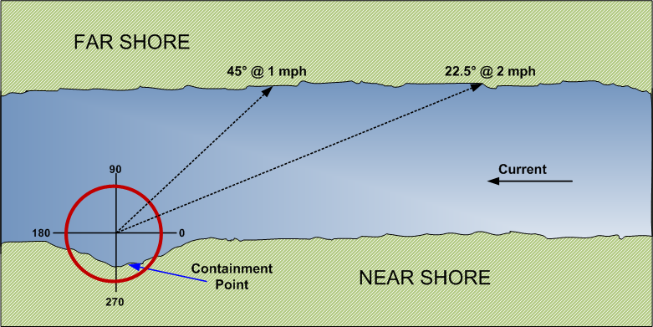

Diversion Boom Deployment

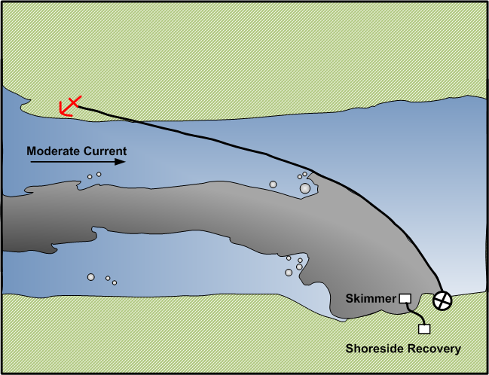

Cascade Boom Deployment

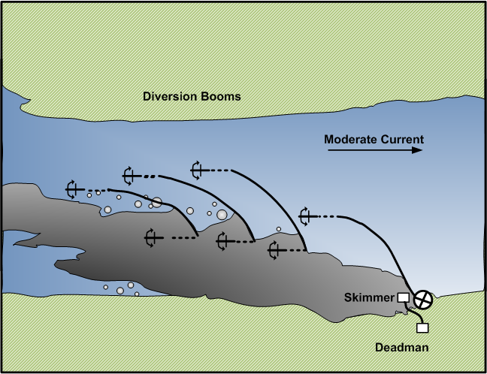

Staggered Chevron Boom Deployment (Typical)

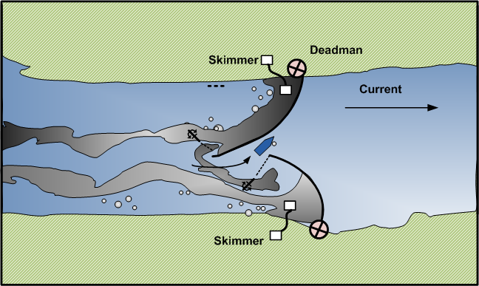
Exclusion Boom Deployment

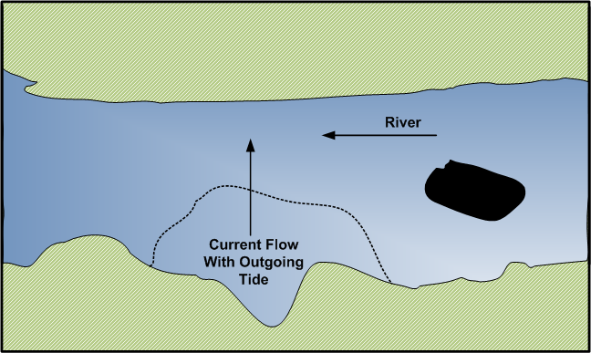

Diversion Boom to Shore Using a Boat

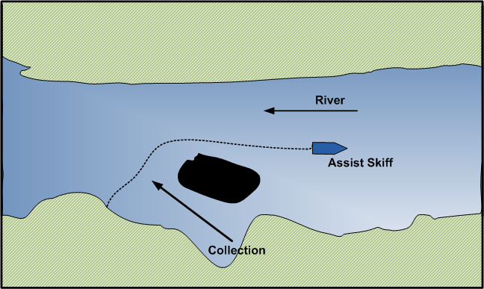
Deflection and Diversion Boom Deployment

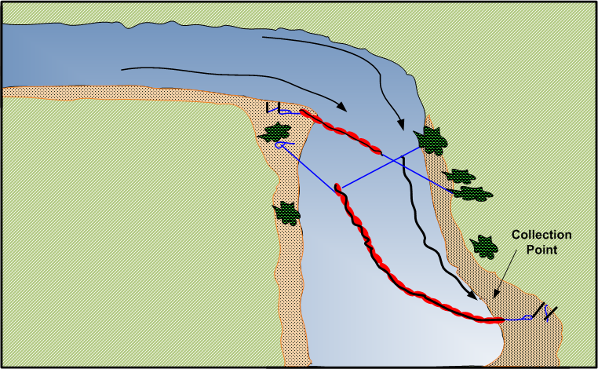

Buoy to Bank Rope Anchor Diversion Boom Deployment (High Flow)

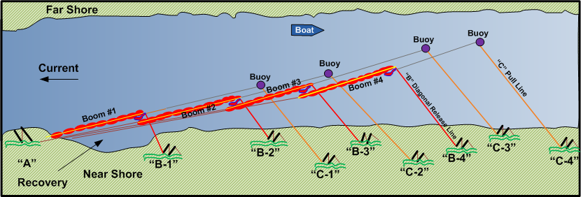

Bridge to Bank Rope Anchor Diversion Boom Deployment (High Flow)

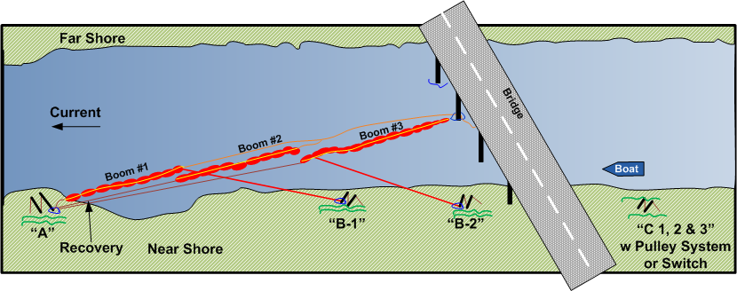

Bank to Bank Rope Anchor Diversion Boom Deployment (High Flow)

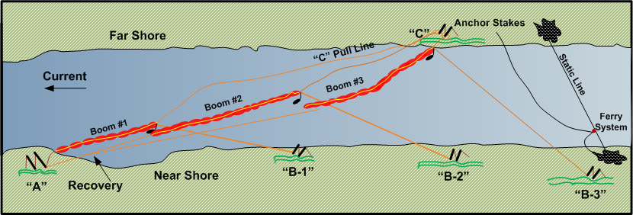

Incident Management

On-Scene Command
Railroad Name recognizes the authority of local emergency response officials to take command of any incident that poses a threat to the health and safety of the general public or the environment. Our supervisory group understands that it is their role at an emergency to work with local officials to bring an incident to a safe conclusion.

Designated railroad personnel and contractors working on the scene of a hazardous materials incident are covered by the U.S. Occupational Safety and Health Administration (OSHA) 29 CFR 1910.120 “Hazardous Waste Operations and Emergency Response” (HAZWOPER) regulations. As instructed in these regulations, we have adopted the National Incident Management System (NIMS) and the Incident Command System (ICS) processes to achieve true unified command incident management of incidents involving oil and hazardous materials, security and incidents and occurrences responded to and from any public emergency response organization (i.e. law enforcement, fire, emergency medical services (EMS) or emergency management), in accordance with the National Response Framework (NRF), The National Contingency Plan (NCP) and Titles 29, 33, 40, 46 and 49 of the Code of Federal Regulations (CFR).

Further, they will work with local officials in a unified ICS as recognized by the U.S. Environmental Protection Agency (EPA) and U.S. Coast Guard (USCG) and cited in the National Oil and Hazardous Substances Pollution Contingency Plan, 40 CFR Part 300. Only fully trained and qualified individuals will be permitted to conduct hands-on technical response activities. Specialized contractors working at the scene will be covered by these regulations and are considered “specialized” employees.

The senior or designated Railroad Name representative will be in charge of all company employees, contractors or other company resources. The Railroad Name official will coordinate with the local emergency response official in charge. Railroad Name will make resources and information available to the local emergency response official to aid in the safe and efficient mitigation of the incident.

It is understood that no company official may commit any resources to any task which would violate local, state or federal laws or statutes, or which would pose an unreasonable risk or safety hazard to any personnel working for Railroad Name.

Current operating and safety rules will be strictly adhered to by all company employees during re-railing or emergency response operations. The senior or designated Railroad Name official on scene is fully responsible for the enforcement of the rules and the conduct of all employees, including both company and contractor personnel.

Guidelines for Determining Incident Levels
Railroad Name has developed an incident level response system based upon the designation of hazardous materials incidents as Level I, Level II, or Level III incidents. Incident response levels are determined based on a variety of hazard assessment criteria, which include:

- Nature of commodity or hazard class;
- Leak severity (amount released);
- location of release (valve versus tank failure)
- accessibility of response equipment to leaking car
- ease of containment (whether or not release can be readily stopped)
- Potential threat to life or safety (including public drinking water supply);
- Fire and/or explosion potential;
- Potential environmental impact to water (including pipes, drains and ditches), land and air;
- Container integrity (whether or not transloading is required);
- Tank car derailment status (upright versus on side); and,
- Oil discharge (locomotive spills).

A guide for determining incident levels is shown at the end of this section.

Level I Incidents
Level I incidents are minor or low risk events that can be readily contained and controlled with available local resources and have no significant environmental impact. Examples include:

- Small release of mildly hazardous materials from a large package (splash out or vapor release from manway or valve on top of tank car, or drip from a valve on the bottom of the tank car);
- Release of mildly hazardous material from a small package (up to a 55-gallon drum), or a small cylinder in a controlled area; and,
- No visible release, vapor or liquids release, but strong odor emitting from a placarded car.

Some generalized example response actions for Level I incidents are as follows:

- If hazardous materials are involved in an incident, but no leakage or threat of leakage is present, actions should be directed to isolate the hazardous materials containers and keep them out of the way until proper arrangements can be made to handle them. Contact shipper emergency response phone number on shipping document for assistance.
- If leakage is of a low risk hazardous material from a small package in a container, or if vapor release or splash out from loose bolts, faulty gaskets, ruptured frangible disk, etc., isolate the car to avoid contact with the material and contact the operations support center and the risk management department personnel. Suitable arrangements will be made to have the package repaired. Place containers and/or absorbent materials under car/container drippage areas to capture spilled material – only if it can be done safely and without risk of exposure.

Level II Incidents
Level II incidents are moderate incidents, which can only be controlled with special resources such as an approved emergency response contractor. These include incidents involving releases from multi-point sources or tank failures; releases which cannot be readily stopped; and incidents where transloading may be required. Examples of a Level II incident include:

- Failure of tank car containing sodium hydroxide (caustic soda) or sulfuric acid;
- Locomotive fuel tank rupture involving spill of a large volume (1,000 – 5,000 gallons) of diesel fuel. Small release of mildly hazardous materials from a large package (splash out or vapor release from manway or valve on top of tank car, or drip from a valve on the bottom of tank car);
- Large release or fire from trailer-load of drums of paint or other flammable liquid;
- Minor release from a tank car containing a toxic inhalation hazard material (i.e. chlorine).

Some generalized example response actions for Level II incidents are:

- Locomotive fuel tank or cargo tank ruptures with releases of large quantities of diesel fuel or similar materials need to be contained as soon as possible to prevent the spread of the material. Absorbent pads and booms can be used on land and water and earthen dikes can be built on land to contain the oil. Health hazards are moderate so long as exposure to the fumes and direct physical contact is kept to low levels. Timely actions to control and contain the spill will minimize environmental damage to plants and animals. Contractors normally will be called to clean up the spilled material and dispose of contaminated wastes.
- Spills of water-based corrosive materials such as sodium hydroxide or caustic soda solutions, and sulfuric acid can cause environmental damage if not contained and can be destructive to people if there is direct physical contact. Vapors or fumes are not usually a major problem unless the materials are hot or unless a person is standing in puddles of the liquids. Containment and neutralization are usual procedures for control. Emergency response contractors would be called to handle large spills.
- The local fire departments and emergency response contractors normally handle releases of flammable liquids and fires involving flammable liquids. The area is isolated to prevent or minimize health, property and environmental damage, and emergency response personnel are called.
- Minor leaks from tank cars containing inhalation hazards, such as chlorine, are handled by isolating the areas, evacuating people as necessary and calling emergency response contractors to handle the incident. Special protection is required for people who attempt to repair the leak. Load transfer might be required.

Level III Incidents
Level III Incidents are major incidents, which cannot be readily stopped. Incident cannot be controlled by local forces and requires special resources to limit potential safety and environmental impacts. Potential threats to the environment or to long-term health public health include examples such as:

- Puncture of tank car loaded with an inhalation hazard material (e.g. chlorine);
- Puncture and/or involvement of a flammable gas (e.g., vinyl chloride, butadiene or a liquefied petroleum gas) tank car in a large fire;
- Car load of pesticides in a navigable waterway (possibly upside down);
- Leaking tank car of a poison that can get into a water source/supply; and,
- Ruptured container of highly flammable liquid that can get into a city sewer or underground storm drain system.

Some generalized example response actions for Level III incidents are as follows:

- Punctures of tank cars loaded with inhalation hazard materials, or tank cars loaded with compressed flammable gases, are often handled by evacuation to a safe distance and waiting until the material has diluted in air sufficiently to approach safely. Only highly trained personnel with proper safety equipment and backup can address these incidents.
- Cars loaded with pesticides or poisons that get into a waterway or can get into a drinking water supply via yard drains need direct and quick action. If the materials are relatively non-volatile liquids such as water-based or oil-based products, the potential for exposure to vapors or fumes might not be significant, whereas direct physical contact could be. In these latter cases, take actions to contain the materials on land and prevent the spread into the water source. As with oil spills, building containment dikes or dams and using absorbent materials would be appropriate. If possible, the cars should be removed from waterways and load transfers made when car repairs are not possible. Emergency response contractors must be utilized.
- As with releases which might contaminate waterways or water supplies, spills of flammable liquids and similar materials that might get into city sewers or underground drains need to be contained and controlled to minimize fire and explosion hazards. Isolating containers, constructing dikes and dams and other actions to prevent the spread of the material are highly desired. Emergency contractors with trained personnel and proper equipment must be used.

Initial Notification Procedures
Railroad Name incident notification procedures differ slightly depending on where the incident is discovered and reported (yard vs. mainline).

In the yard, company personnel report all incidents to the (Fill in yardmaster or trainmaster, etc.), who then contacts the local Fire and Police departments using 911 when/where available.

On mainline reporting of incidents, Railroad Name personnel report all incidents to _Fill in internal contact point_____. Reporting of the incident to local Fire and Police departments would be accomplished by Fill in responsible person or group, to 911, when/where available.

Local Fire and Police departments must be notified if any one of the following criteria is met:

- Fire, smoke, violent ruptures, and/or explosions;
- Leaking tank cars placarded poison gas or flammable gas;
- Leaking tank cars with moderate or major leaks (Level II or III Incidents);
- Leaks (hazardous or non-hazardous) which enter yard drains, drainage ditches, culverts, sewers or water courses or threaten to do so;
- A situation exists of such a nature (i.e., a continuing danger to life and health exists at the scene of the incident) that, in the judgment of the carrier, should be reported even though it does not meet above criteria;
- Spills, discharges or releases that go or threaten to go beyond company property or create an emergency situation or result in an evacuation; or,
- Any other situation as deemed appropriate by the individual making the notification calls.

Responsibilities
Actions of Railroad Name personnel will be determined by the nature and circumstances of the hazardous material and/or environmental incident.
After being notified of a hazardous material or environmental incident, shall contact the following;

- For chemical release or main line incidents Fill in internal group/person responsible for emergency notifications contacts
- National Response Center
- The shipper of the affected railcar(s) by utilizing the 24-hour emergency response phone number designated on the shipping documents;
- State and/or Federal agencies, as dictated by regulatory requirements, and/or directed by the Railroad Name leadership; and/or,
- Other appropriate company personnel as deemed necessary.

After initial notifications are completed, the Railroad Name ranking individual on site will continue to coordinate the response by providing a central point of contact, until command can be established at the affected site.

Emergency Response Contractors
In the case of most major derailments or spills, local responders do not have the equipment or expertise to handle large spill cleanup or railroad re-railing operations. Railroad Name recognizes its role in providing this specialized expertise and equipment to mitigate an incident, and maintains standing contracts and agreements with various suppliers of these services.

While on scene, these contractors act as agents of Railroad Name, and work directly under Railroad Name’s control. Examples of services these contractors provide are as follows:

- Railroad re-railing and wreck response contractors provide heavy equipment such as cranes, off track lifting equipment, heavy earth moving equipment, and the operators and ground crews to lift and re-rail damaged rail cars and locomotives;
- Emergency response (hazardous material/environmental) contractors provide vacuum equipment, pumping equipment, etc. and cargo tanks for the recovery of spilled product(s);
- Personnel are trained and equipped with all levels of personal protective equipment (PPE) for operations in close proximity to spilled products, and leak and spill control equipment to contain product from leaking containers;
- Containers and heavy equipment are available for recovery of solid materials;
- Environmental recovery contractors provide technical expertise in the on-site remediation or removal of contaminated soil or debris from the incident site;
- Industrial hygiene and public health contractors provide technical expertise and equipment to perform on/off-site air and water sampling; and/or,
- Contractors are used to develop exclusion zones and work zones, and to document public health exposure safety.

Guidelines for Determining Incident Level and Response

Incident Conditions |  | Level I |  | Level II |  | Level III
Commodity or Hazard Class |  | Low hazard  RQ = 5,000 or 1,000 lbs.  Class 2.2, 3, 8, 9, C.L. |  | Medium hazard  RQ = 100 lbs.  Class 3, 4, 5 |  | High hazard  RQ = 10 or 1 lb(s).  Class 1, 2.1, 2.3, 6, 7, ESC, PIH, HW, MP
Leak Severity, Amount Released |  | Minor: Can be contained or controlled with readily available resources |  | Medium: Can be controlled only with special resources |  | Major: May not be controllable even with special resources
Life/Safety Impact |  | No life-threatening situation from material involved, no evacuation |  | Localized area, minimum evacuation |  | Large areas, mass evacuation
Fire/Explosion Potential |  | Low |  | Medium |  | High
Environmental Impact (Air, Land, Water) |  | Minimal, no long-term damage |  | Moderate, long-term damage possible |  | Major, long-term damage likely
Potential Property Damage |  | Low  < $10,000 |  | Medium  $10,000 - $50,000 |  | High  > $50,000
Container Integrity |  | Not damaged |  | Damaged but will contain contents to allow handling or transfer of product |  | Damaged to such an extent that catastrophic failure is possible
Tank Car Derailment Status |  | Car on rail, wheel(s) derailed with car upright |  | Loaded hazmat tank care not upright |  | Multiple losses, hazmat cars not upright
Oil Discharge (Locomotive Spills) |  | Fuel spill of less than 1,000 gallons into environment |  | Fuel spill of 1,000 – 5,000 gallons into environment |  | Fuel spill of more than 5,000 gallons into environment
Notes: | CL = Combustible liquid  MP = Marine Pollutant |  | ESC = Environmentally sensitive chemical  PIH = Poison Inhalation Hazard |  | HW = Hazardous waste  RQ = Reportable quantity

One-time Movement Approval Procedures

Hazardous Materials Guidance
Federal Railroad Administration, Office of Railroad Safety, Hazardous Materials Division
1200 New Jersey Avenue SE, Washington, DC 20590
Issue Date: October 7, 2014 | HM Guidance Number: HMG-127
Revision: 4 | 49 CFR Section(s) Affected: 174.50
Page: 1 | Key Words: one-time movement approval (OTMA), leaking, defect, nonconformance, bulk package, bulk packaging, valve, fitting

ONE-TIME MOVEMENT APPROVAL PROCEDURES

Introduction
Since 1996, the Federal Railroad Administration (FRA) has had the authority to issue one-time movement approvals (OTMA) for bulk packages/packaging that no longer conform to the Hazardous Materials Regulations (HMR; Title 49 Code of Federal Regulations (CFR) Parts 171-
180). In 2000, that authority was expanded to cover all bulk packages of hazardous materials (e.g., covered hopper cars, gondola cars, and portable tanks). These changes to the regulations greatly improved the process of gaining approval to move a hazardous material rail shipment that no longer conformed to the HMR. The requests for movement approvals vary from jacket damage that result in a non-weather-tight condition to those with through-shell cracks that result in the release of a hazardous material. As a practical matter, the safety risks associated with the movement of a bulk package/packaging with a small dent in its jacket are significantly different than those associated with a leaking bulk package/packaging loaded with a hazardous material, and those situations must be dealt with differently.
Given the number of requests and the range of possible nonconforming conditions and respective safety risks, FRA has modified the OTMA process. The changes result from reviewing OTMA data, incorporating prior hazardous materials guidance notices, recommendations from a 2011 Peer Review, and comments submitted to Docket Number FRA-2011-0004.
The FRA Hazardous Materials Division (FRA-HM) has an established procedure for evaluating and issuing an OTMA for nonconforming or leaking packages per Title 49 Code of Federal Regulations (CFR) Section 174.50, Nonconforming or leaking packages. The applicant must submit information detailing the nonconforming conditions. The collection of this information is authorized under 49 CFR § 171.6, Control numbers under the paperwork reduction act, and OMB Control Nos. 2137-0557 and 2137-0059. FRA-HM personnel evaluate the information in order to determine whether it is safe to move the bulk package/packaging, and what conditions should apply to the movement. If it can be safely accomplished, the move is authorized by the issuance of a signed FRA OTMA for an OTMA-1 category approval, or an email authorization for an OTMA-2 category approval (applicable only to bulk package shipments that are identified as being overloaded by weight). If the defective condition for a bulk packaging/package falls into an OTMA-3 category approval (referred to as a "standing approval"), then this signed FRA Hazardous Materials Guidance Notice (HMG-127) serves as the authorization for movement.
FRA-HM personnel have evaluated this process over the years and understand the range of defective conditions and their respective frequencies. In addition, there is a growing awareness of the requirement for obtaining an OTMA to move nonconforming bulk packages/packaging, as evidenced by the continually increasing number of requests processed by FRA. A revised process providing greater efficiency without compromising any advances in safety is needed. The OTMA procedures were drafted with the goals of streamlining the process and allowing FRA-HM to monitor nonconformance more productively.
Procedures
This Hazardous Materials Guidance document contains the procedure to be followed by the regulated community to obtain approval to move a noncompliant bulk package. There are three categories of OTMA. The categories are as follows:
- OTMA-1 adheres to the traditional process.
- OTMA-2 requires notification for FRA followed by acknowledgement from FRA in the form of an email authorizing or prohibiting continued movement.
- OTMA-3 is a standing approval.
Each category is described in detail in the following sections. Listed below are general requirements and limitations of the OTMA process.
- Approvals for bulk packaging that are actively leaking will generally not be issued; however, they may be moved "only so far as necessary to reduce or to eliminate an immediate threat or harm to human health or to the environment when it is determined its movement would provide greater safety than allowing the package to remain in place." 49 CFR § 174.50. By submitting a request for OTMA the applicant is certifying the package is not actively leaking and will not leak during transportation as per 49 CFR § 173.24, General requirements for packaging and packages.
- Approval is needed to move nonconforming U.S. Department of Transportation (DOT) specification bulk packaging, or other bulk packaging containing a regulated hazardous material, even if it is secured in or on a rail car. Approval is also needed to move any nonconforming DOT specification bulk packaging even if the DOT specification bulk packaging does not contain a regulated hazardous material as long as the bulk packaging is offered or to be offered and represented in transportation as a DOT specification package (see 49 CFR § 171.2(g)). Approvals will not generally be granted to move tank cars that are overloaded by volume and have insufficient outage in the tank for the products they contain. In these instances, shippers will need to arrange for transloading with the rail carrier in possession of the shipment.
- FRA cannot issue movement approvals for bulk package/packaging that are offered into transportation for interchange service and exceed the age limits prescribed in the Association of American Railroads' (AAR) Interchange Rules, Rule 90. This is not a Federal regulatory age limit, and persons with cars affected by this will need to seek resolution with the Association of American Railroads and the rail carriers involved.
- An approval issued by FRA is only applicable to movements of a defective bulk package/packaging by rail within the United States. Authorized movement of defective bulk package/packaging in Canada requires the issuance of a "temporary certificate" from the appropriate representatives of Transport Canada. The requestor will need to coordinate the request and obtain corresponding approval from Transport Canada for cross-border movement of nonconforming bulk packages/packaging. Movement of defective bulk packages/packaging across the border, to or from Mexico, also requires an applicant to coordinate with the appropriate Mexican agency representatives.
- For the purpose of this document, FRA will assume an empty bulk package contains residue unless a cleaning certificate is provided.
- This document addresses movement approvals of a bulk package/packaging that no longer conforms to the HMR, and provides no relief from any regulation other than as specifically related to the nonconforming condition for which the OTMA was granted. The approval to move a railcar that does not conform to the regulations in Subtitle B of 49 CFR Parts 200-299 must be obtained from FRA's Motive Power and Equipment Division.
- Rail carriers are not obligated to honor an approval issued by FRA, and have the right to refuse movement even if an approval is issued. A rail carrier may require alternate solutions that do not involve further movement on its rail system. FRA strongly urges that the applicant contact appropriate representatives from the rail carriers that will be involved in moving the defective packaging prior to submitting the approval request. This will ensure that the rail carriers are willing and able to conduct transportation of the packaging on their respective systems in order to get the packaging to the requestor's desired location upon issuance of an approval by FRA.
- The requestor is required to maintain information regarding movements, subject to this document, and must make it available upon request to FRA personnel (Paperwork shall be retained per 49 CFR § 172.201, Preparation and retention of shipping papers).
- Failure to comply with the provisions of this document may result in recommendations for enforcement and civil penalties. Furthermore, FRA may issue written notification to any entity found to be noncompliant with the procedure specified in this document requiring that entity to submit all future OTMA requests in accordance with the procedures specified for OTMA-1 regardless of the identified defect. This limitation will apply to the particular entity until otherwise notified by writing by FRA.
- FRA reserves the right to change the contents of this document as conditions require. Additionally, at any point where safety may be compromised, FRA reserves the right not to issue an approval.
OTMA-1 (Traditional)
An OTMA-1 follows the traditional approval process and applies to any non-conforming package/packaging that does not meet the criteria for movement as OTMA-2 or OTMA-3 in this document. All requirements related to the continued movement of the nonconforming rail car or other bulk packaging will be detailed in the signed OTMA, which will be sent to the applicant via fax or email.
Submit the following information with the one-time movement request for the specified noncomplying conditions. This information will permit an evaluation of the defective condition and determination of whether the bulk package/packaging can be moved safely. When photographs are requested, appropriate views should include both an overview of the car, defect, and fittings as well as clear, close up views of the fitting or defect. Also helpful are photographs of the car stenciling, including specification and qualification information. Failure to provide the information below will result in delay in evaluation or denial of your request.
Breaches in tank shell and cracks in the underframe:
- Dimensions, locations, and orientations of cracks.
- Photos or diagrams that provide perspective of location.
- Photos of the breaches and cracks.
- Data (facility, date, and inspection records related to the area with a defect) regarding most recent qualification.
Defective valves and fittings (service equipment) that do not qualify for OTMA-3:
- Photos of fittings arrangement.
- Orientation of fittings arrangement indicating the "A" or "B" ends of the car.
- Make/model of defective fittings.
- Data (facility and date) regarding installation or most recent qualification.
- Location of defect (i.e., at gasket, ball, stem, etc.).
This list identifies the types of information FRA typically requires for processing most OTMA requests. However, some nonconforming conditions may require other types of information not identified in this section. Also, providing accurate and complete information on what actions or measures have been taken, if any, to mitigate the defective condition prior to movement of the bulk packaging will assist the FRA Headquarters Hazardous Materials (HQ HM) Specialist in his or her evaluation of the approval request.
OTMA-2 (Written Notification)
An OTMA-2 applies to railcars found to be overloaded by weight. An applicant must submit written notification to FRA containing information related to the nonconforming condition and shipping papers for the bulk package/packaging. In addition, FRA is requesting the following information be submitted to facilitate processing:
- Scale tickets.
- Loading temperature and specific gravity of commodity at the loading temperature in accordance with 49 CFR 173.24b(a), Additional general requirements for non-bulk packaging and packages.
- Specific gravity of commodity at appropriate reference temperature.
- Capacity (in gallons) and tare weight of bulk package/packaging.
- Innage/outage table for the tank car.
- Any additional information that can be used to demonstrate that the tank car is not overloaded by volume.
After the information is received, evaluated, and approved, the grantee will receive notice, via fax or email, that the review was completed and movement is authorized under this OTMA category. The grantee will be required to ensure that the words, "Moving per 174.50: OTMA-2," are placed on all shipping documentation that is transmitted to each rail carrier involved in the movement of the nonconforming shipment in a location that clearly associates the notation with the basic shipping description. Additionally, a grantee of an OTMA-2 must comply with the General Requirements section of this document unless otherwise exempted through written acknowledgement from FRA. An OTMA-2 will be applicable for bulk package/packaging, or other railcars (e.g., covered hopper cars containing a regulated hazardous material), that are found to be overloaded by greater than 1 percent of the allowable total gross rail load (GRL), rounded up to the next 100 pounds on a weight-in-motion scale; or for any bulk package/packaging that is overloaded by greater than 1,000 pounds of the allowable total GRL on a static scale.
The grantee will have 60 days from the date of FRA's written OTMA-2 approval to move the bulk package to the destination specified in the approval request.
OTMA-3 (Standing Approval)
An OTMA-3 applies to bulk packages/packaging that meet the specific criteria (listed below) for movement as an OTMA-3 may be moved under an OTMA-3 standing approval. A bulk package/packaging involved in a non-accident release may not be moved under an OTMA-3 unless authorized by an FRA HQ HM Specialist. Persons in possession of a nonconforming bulk package/packaging containing PIH (loaded or residue) may not use the provisions of OTMA-3 unless approved to do so by an FRA HQ HM specialist.
A standing approval allows for the movement of the car without response from FRA provided that an accurate and complete OTMA-3 notification (described below) is submitted, in which the defect is one specifically described in listed Defect # Descriptions below and complies with the applicable OTMA-3 and general requirements in this notice.
An OTMA-3 is an approval that will be used for a specific list of nonconforming conditions. Persons in possession of a nonconforming bulk package/packaging will be permitted to use the standing approval provisions of OTMA-3. Prior to offering a nonconforming bulk package/packaging under this category for transportation, an email must be submitted to: HMASSIST@dot.gov to notify FRA of the movement. At a minimum, the subject line of the email must include the notation "OTMA-3/Car Mark and Number/Name of Applicant." The body of the email must contain the following information:
Moving per 49 CFR 174.50 (OTMA-3): Car Number(s):
DOT Specification/ Package Stenciled Specification: Loaded or Residue or Cleaned and Purged: Commodity Name and UN/NA number:
Grantee: Contact Name:
Contact Telephone/Email: (of all personnel knowledgeable about issue):
Defect Number and Description of the Problem:
Present location (Facility/Railroad Name, City, State): Destination (Facility Name, City, State):
Routing:
Bulk package/packaging must be stenciled, decaled or tagged with the following message:
"Home shop for repairs, do not load"; "Moving for dismantling,
do not load"; or other words to convey a similar meaning,
as appropriate.
For all shipping papers transmitted or provided to each rail carrier involved in the movement of the nonconforming shipment, each person implementing this category will be required to include a description of nonconformance and the words, "Moving per 174.50: OTMA-3," along with the identity of the destination facility. Each applicant must also keep a copy of the shipping paper and a description of the nonconformance on file per the requirements of 49 CFR § 172.201. For movements that do not require shipping papers per the HMR, this information is required on shipping documentation transmitted or provided to each rail carrier involved in the movement of the nonconforming bulk package/packaging (e.g., a waybill for the defective package/packaging).
Movement under this standing approval is authorized only for the purpose of moving a bulk package/packaging for cleaning, repair, or dismantling; or continued movement for unloading followed by cleaning, repair, or dismantling, and the car is represented as meeting its DOT specification. A grantee of an OTMA-3 must also satisfy the General Requirements section of this document.
Applicability for movement under an OTMA-3:
- Loaded bulk packages (regulated material only)
- Clean bulk packaging (cleaning certificate required)
- Residue bulk packages (regulated material only)
- Bulk package containing (loaded or residue) a nonregulated material
The nonconforming, circumstances, and/or conditions covered by this category, along with the applicability, are as follows:
OTMA-3 Defect Numbers and Descriptions
Service Equipment-Top Fittings
Defect No. 1 | Following replacement of a valve or fitting, with a nondefective valve or fitting, or closure to prevent the release of material (e.g., replacement of a defective vacuum relief valve with a pipe plug, or a liquid or vapor valve with a blind flange). A pressure relief device may only be replaced in kind. Applicability: A, B, C, D
Defect No.2 | For repair (other than removal of the fitting) performed on a connection that is subject to qualification/requalification. This includes, but is not limited to, replacement of hinged manway cover eye bolts, external "0" rings on safety relief valves, tightening securement fasteners that does not result in damage or deformation of the stud or bolt securing an operating valve stem packing gland nut (other than a top operated bottom outlet). Applicability: A, B, C, D
Defect No.3 | A bulk package/packaging with defective manway cover securement bolts where the number of defective manway cover securement bolts does not prevent achieving an adequate seal of the manway cover that would allow the cars to remain in compliance with 49 CFR § 173.24(b)(1) for the duration of the movement to the destination. Applicability: B, C, D
Defect No.4 | A bulk package/packaging with missing or damaged service equipment parts, provided the service equipment is free from leakage (e.g., missing magnetic gauging device rod, top or bottom valve handles, a quick-inspect port cable, or pipe-plug chain). Applicability: A, B, C, D
Defect No.5 | A bulk package/packaging requiring a leakage pressure test to verify the integrity of the completed repairs. Applicability: B, C, D
Defect No.6 | A clean bulk packaging without damage to the tank. Applicability: B
Defect No.7 | A general-purpose bulk package/packaging (tank car) that has damage to the protective housing. Applicability: A, B, C, D

Service Equipment-Bottom Fittings
Defect No. 8 | Defective bottom outlet valve, provided the material is contained by the application of the secondary closure. This does not include the flanged connection between the valve and tank, or any other damage inboard of the primary valve. Applicability: B, C, D
Defect No.9 | A bulk package/packaging that has the primary bottom discontinuity closure intact, but has incurred damage to the secondary closure portion of the bottom discontinuity and/or bottom discontinuity protection. Applicability: B, C, D
Defect No. 10 | Securing an operating valve stem packing gland nut. Applicability: A, B, C, D

Interior Coating/Lining
Defect No. 11 | A bulk package/packaging with a defective interior lining or coating that has not resulted in damage to the tank (bulk packages/packaging with a defective coating or lining installed for product purity is not subject to these safety measures). Applicability: B, C, D

Heater Coils
Defect No. 12 | A bulk package/packaging with a defective interior heater coil. Applicability: B
Defect No. 13 | A bulk package/packaging with a defective exterior heater coil provided the defect does not introduce a flow path into the product space or otherwise compromise the integrity of the tank. Applicability: A, B, C, D

Jacket/Insulation
Defect No. 14 | A bulk package/packaging that has incurred damage solely to its jacket, such that the jacket is no longer "weather-tight," provided there is no damage to the tank. Applicability: A, B, C, D

Derailment Damage
Defect No. 15 | A bulk package/packaging with damage resulting from a collision or derailment, which is loaded onto or into another rail car conveyance such as a flatcar or gondola car. Applicability: B, C

Marking/Stenciling
Defect No. 16 | A bulk package/packaging with faded, unreadable or missing markings that are required under 49 CFR § 172.330(a)(1)(ii) and § 179.22 (e.g., DOT packaging specification number, proper shipping name, and qualification due dates), provided that the markings are reapplied at the destination that the bulk package/packaging is being moved to. This provision does not apply to identification number markings, inhalation hazard markings, marine pollutant markings, or any other required markings pertaining to the regulated product, except as stated above. Applicability: A, B, C, D

OTMA Flowchart

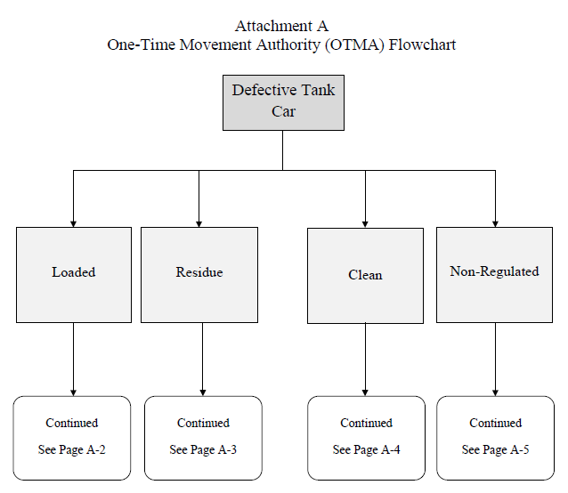

Loaded A-2
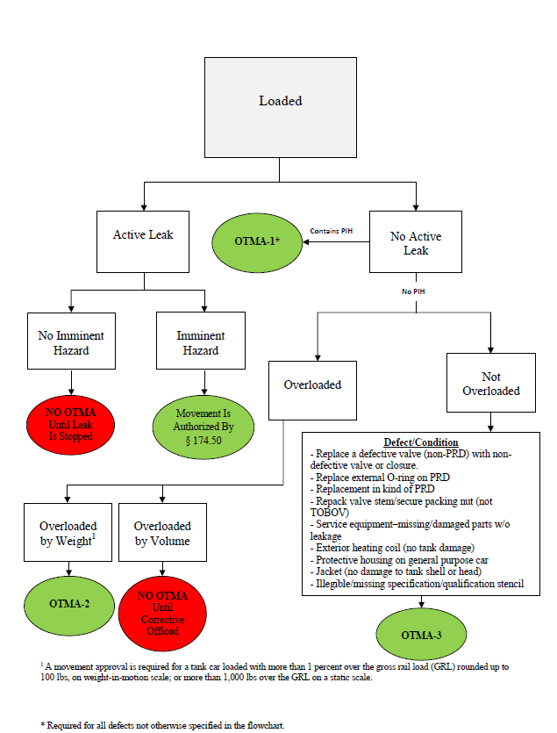

Residue A-3
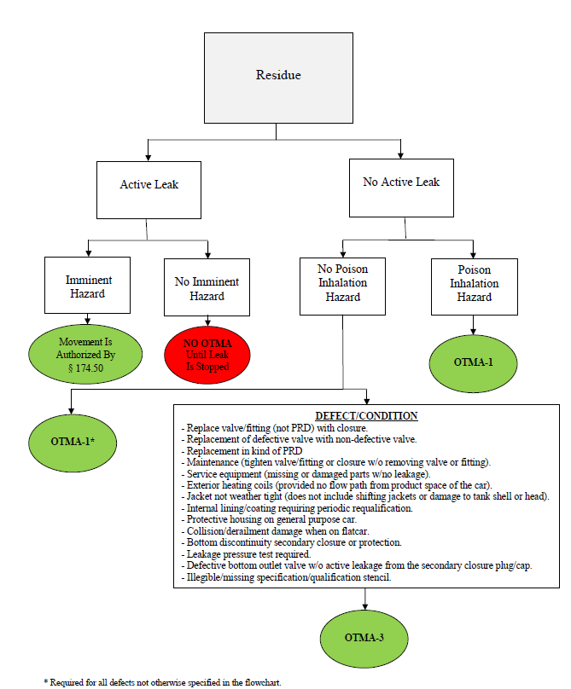

Clean A-4
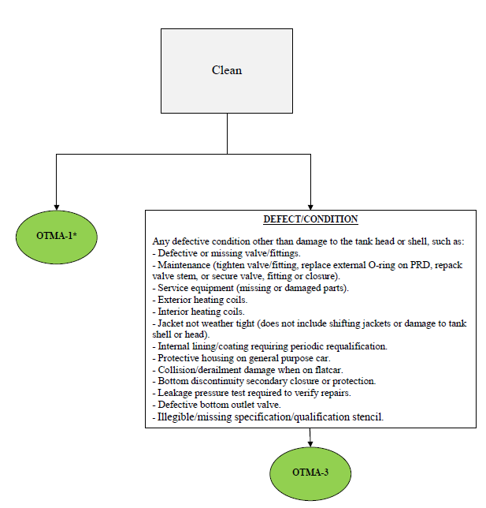

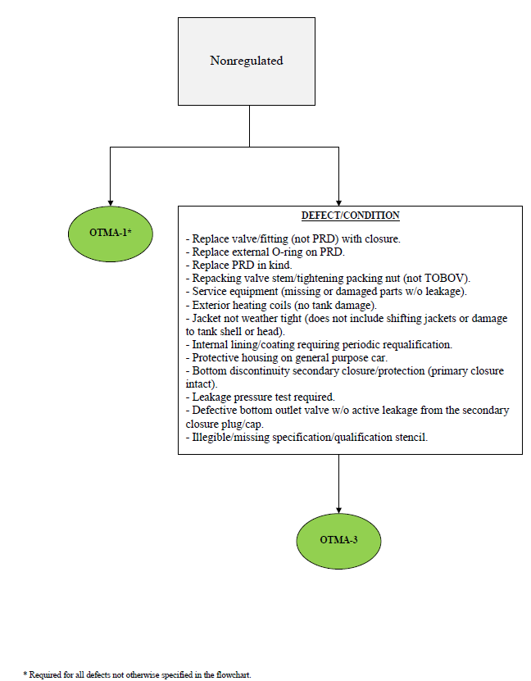
Nonregulated A-5

OSRO Registrations and Classifications
The U.S. Coast Guard (USCG) manages the Oil Spill Removal Organization (OSRO) program, which was founded through an amendment by the Oil Pollution Act of 1990 to the Federal Water Pollution Control Act. This program provides a reliable method to ensure organizations listed in the program have all necessary personnel, training and resources available to respond to and mitigate certain levels of oil discharged in an accident or spill. The levels of classification are determined by the base amount of resources available, and the amount of time it takes to get all necessary resources on-scene to satisfy worst case discharge (WCD) requirements. The current level of classification of an individual OSRO contractor can be found on the USCG website at: https://cgrri.uscg.mil/UserReports/WebClassificationReport.aspx

- WCD – Worst Case Discharge: The largest possible, or foreseeable, discharge in adverse weather conditions.  - COPD – Captain-of-the-Port District  - MMPD – Maximum Most Probable Discharge  - WCD 1 – Worst Case Discharge 1  - WCD 2 – Worst Case Discharge 2  - WCD 3 – Worst Case Discharge 3 | Please note: Effective Daily Recovery Capacity (EDRC) and Temporary Storage Capacity (TRC) volumes are in barrels per day and barrels, respectively, not gallons.  1 barrel = 42 US gallons.

 | Facility (barrels) | Vessel (barrels)
MMPD | 1,200 or 10% of WCD | 2,500 or 10% of WCD
WCD | Largest possible discharge in  adverse weather conditions | Entire Volume

 | Protective Boom | Containment Boom | EDRC (barrels) | TSC | Facility RT (hours) | Vessel RT
MMPD | 4,000 | 1000;  300 / recovery device | 1,200 | 2,400 | 6 (HVP)  12 | 12 (HVP)  24
WCD 1 | 25,000 | 1000;  300 / recovery device | 1,875 | 3,750 | 6 (HVP)  12 | 12 (HVP)  24
WCD 2 | 25,000 | 1000;  300 / recovery device | 3,750 | 7,500 | 30 (HVP)  36 | 36 (HVP)  48
WCD 3 | 25,000 | 1000;  300 / recovery device | 7,500 | 15,000 | 54 (HVP)  60 | 60 (HVP)  72

OSRO Listed Organizations (9-2018)

State | City | Organization Name | OSRO Number | Business Phone
AK | Valdez | Alyeska Pipeline Service | 77 | (907) 834-6974
AK | Ketchikan | SEAPRO | 88 | (907) 225-7002
AK | Prudhoe Bay | Alaska Clean Seas | 89 | (907) 659-3207
AK | Anchorage | Alaska Chadux Corporation | 93 | (907) 348-2365
AK | Anchorage | ASRC Energy Services | 165 | (907) 223-9935
AK | Seldovia | Nuka Research | 193 | (907) 234-7821
AK | Juneau | D17 DRAT-USCG | 235 | (907) 463-2807
AK | Anchorage | Aleutians Spill Control, Inc. | 338 | (907) 222-7500
AK | Valdez | Environmental Remedies, LLC | 341 | (660) 541-4149
AK | Valdez | BellTech Inc. | 381 | (907) 602-0111
AK | Anchorage | SolstenXP, Inc. | 500 | (907) 264-6107
AK | Anchorage | UIC Arctic Response Services | 554 | (907) 865-4910
AK | Juneau | ADEC | 623 | (907) 465-5234
AK | Valdez | Kimberlin’s Water Taxi LLC | 649 | (907) 835-8294
AK | Anchorage | PPR Alaska | 661 | (907) 337-3949
AK | Nikiski | Cook Inlet Spill Prevention &Response Inc. | 662 | (907) 776-5129
AK | Anchorage | PPR Alaska | 664 | (907) 868-3661
AK | Cordova | Native Village of Eyak | 695 | (907) 424-2231
AK | Anchorage | Resolve Marine Services Alaska Inc | 767 | (907) 243-0069
AL | Mobile | Oil Recovery Company, Inc. | 73 | (800) 350-0443
AL | Irvington | Wonderland Express | 337 | (251) 653-7348
AL | Bay Minette | Complete Environmental | 343 | (251) 580-9400
AL | Daphne | Blake Marine Group | 389 | (504) 343-6475
AL | Foley | GreenCo Services LLC | 398 | (251) 971-2210
AL | Gulf Shores | Ike’s Beach Service | 401 | (251) 948-3757
AL | Theodore | Crowder Gulf | 415 | (678) 477-3755
AL | Mobile | Alabama State Port Authority | 566 | (251) 441-7074
AL | Creola | Ranger Environmental Services, LLC | 603 | (251) 679-8611
AL | Mobile | United States Environmental Services | 761 | (228) 234-4447
AR | Texarkana | Hazmat Services Inc | 525 | (870) 330-4535
AR | El Dorado | Code 3 Services, LLC | 642 | (870) 875-1521
AR | Leachville | RPW | 679 | (870) 450-8430
AR | Marion | Loenbro Environmental Services LLC | 738 | (901) 502-4109
AR | Blytheville | Boomer Environmental | 787 | (580) 327-7500
AZ | Mohave Valley | Metropolitan Marine Solutions | 287 | (818) 398-6635
AZ | Tempe | Environmental Response, Inc. | 317 | (480) 967-2802
CA | Carpinteria | Clean Seas, LLC | 44 | (805) 684-3838
CA | Terminal Island | SoCal Ship Services | 63 | (310) 519-8411
CA | PORT HUENEME | Tractide Marine Corporation | 70 | (805) 488-8788
CA | Carson | Ancon Marine, Inc. | 97 | (310) 522-5110
CA | Wilmington | Patriot Environmental Services | 146 | (800) 624-9136
CA | Rancho Dominguez | Advanced Cleanup Technologies | 152 | (800) 334-2284
CA | San Diego | NRC Environmental Services Inc | 197 | (619) 235-3328
CA | Long Beach | Ocean Blue Environmental Services, Inc. | 240 | (562) 624-4120
CA | Rancho Dominguez | Double Barrel Environmental Services | 320 | (424) 344-0060
CA | San Diego | Action Cleaning Corp | 342 | (619) 233-1881
CA | Long Beach | O.C. Vacuum, Inc. | 345 | (562) 984-8178
CA | Oxnard | Black Gold Industries | 380 | (805) 981-4616
CA | Benicia | Clean Harbors Environmental | 396 | (707) 758-3188
CA | Nevada City | Lukins & Associates | 481 | (530) 402-5093
CA | Discovery Bay | Sean Alexander Marine Services, Inc. | 553 | (925) 634-8744
CA | Long Beach | Ocean Blue Environmental Services | 676 | (562) 624-4120
CO | Denver | Strad Energy Services USA, LTD | 325 | (720) 292-2204
CO | Arvada | Custom Environmental Services, Inc. | 663 | (303) 423-9949
CT | Durham | Alpine Environmental Services LLC | 177 | (860) 346-0027
CT | South Windsor | Environmental Services, Inc. | 312 | (860) 528-9500
CT | Bridgeport | Connecticut Tank Removal, Inc. | 353 | (203) 384-6020
CT | New London | Kennedy Marine, Inc | 435 | (860) 442-6000
CT | Woodbury | Tom Ashmore Enterprises Inc | 606 | (609) 332-1108
FL | Jacksonville | Jacksonville Pollution Control, Inc. | 6 | (904) 355-4164
FL | Tampa | Diversified Environmental Services, Inc. | 37 | (813) 248-3256
FL | Fort Lauderdale | Cliff Berry, Inc. | 48 | (954) 763-3390
FL | Pompano Beach | Offshore Marine Towing Inc. | 198 | (954) 783-7821
FL | Panama City Beach | SWS Environmental Services | 247 | (800) 852-8878
FL | Fort Lauderdale | Resolve Marine | 250 | (954) 764-8700
FL | Key West | AIM Companies, LLC | 251 | (305) 294-1124
FL | Tampa | USF Coastal Research Lab | 294 | (850) 862-7134
FL | Orlando | Best Environmental | 324 | (407) 380-2000
FL | Atlantic Beach | Intra Coastal Environmental | 326 | (904) 553-0266
FL | Jacksonville | Aquilex - Hydrochem | 388 | (904) 781-7913
FL | North Bay Village | Sea Tow Miami | 433 | (305) 673-2869
FL | Miami | Adventure Environmental, Inc. | 442 | (305) 254-8887
FL | Big Pine Key | Coffin Marine Services Inc | 443 | (305) 872-8863
FL | Sarasota | Ceres Environmental | 464 | (800) 218-4424
FL | Fort Lauderdale | RESOLVE SALVAGE & FIRE (Americas), INC. | 466 | (954) 764-8700
FL | Orlando | FCC Environmental, LLC | 503 | (407) 466-4085
FL | Fort Lauderdale | Drew Fuel Services | 545 | (888) 620-6807
FL | Minneola | Incident Management Solutions | 585 | (352) 242-9621
FL | Cocoa | Alpha-Omega Training & Compliance, Inc. | 599 | (321) 445-9845
FL | Fort Lauderdale | Oil Spill Response Limited | 620 | (954) 983-9220
FL | Saint Petersburg | Metanomy, Inc | 629 | (184) 365-4708
FL | Jupiter | Advanced Fuel Technologies | 636 | (844) 238-3835
FL | Fort Lauderdale | Oil Spill Response Limited | 645 | (954) 983-9880
FL | Bartow | American Compliance Technologies | 650 | (800) 226-0911
FL | Port Orange | Salty Marine Services, Inc. | 657 | (386) 547-3965
FL | Miami | E.M.C. Oil Corp | 658 | (305) 477-7497
FL | Tampa | Citgo Tampa | 672 | (813) 247-3429
FL | Orlando | FECC, INC. | 745 | (813) 842-5520
FL | Miami | Kearns Construction Company | 773 | (305) 461-0310
FL | Bartow | American Compliance Technologies, Inc. | 774 | (863) 533-2000
FL | Pensacola | Aquanaut Towing & Salvage | 782 | (850) 492-5070
FL | Pensacola | Aquanaut Towing &Salvage Inc. | 792 | (850) 492-5070
GA | Savannah | EnviroVac Holdings, LLC. | 252 | (800) 822-3044
GA | Brunswick | LobePro Rotary Lobe Pumps | 293 | (912) 466-0304
GA | Roswell | TransMontaigne | 360 | (770) 518-3701
GA | Marietta | Remtech Engineers | 382 | (770) 427-7766
GA | Snellville | Basha Services, LLC | 383 | (678) 344-1161
GA | Palmetto | Rhino Services, LLC | 384 | (770) 317-4649
GA | Atlanta | Kemron/CMC Environmental Services | 437 | (404) 601-6926
GA | Savannah | EnviroVac Holdings LLC | 673 | (800) 822-3044
GA | Savannah | EnviroVac Holdings LLC | 674 | (800) 822-3044
IA | Davenport | Environmental Management Services, Incorporated | 359 | (800) 457-1042
IA | Des Moines | Hydro-klean, LLC | 747 | (515) 283-0500
ID | Boise | H2O Environmental | 147 | (702) 985-7641
IL | Wheeling | SET Environmental Inc | 245 | (847) 537-9221
IL | Mokena | Future Industrial Services Inc. | 350 | (708) 479-6900
IL | Chicago Heights | Ziron Environmental Services, Inc. | 399 | (708) 757-9601
IL | Chicago | BP | 592 | (312) 594-2059
IL | South Roxana | Jarrett Industries, Inc. | 692 | (618) 251-4116
IL | Roxanna | Dynamic Enviro Inc. | 711 | (228) 231-1187
IN | Indianapolis | Heritage Environmental Services, Inc. | 45 | (317) 243-0811
IN | Evansville | Summit Environmental Services | 107 | (812) 421-1744
IN | East Chicago | National Industrial Maintenance Inc. | 158 | (219) 398-6660
IN | Hanover | Sam George and Associates LLC | 308 | (812) 701-9641
IN | Merrillville | BP US Pipelines & Logistics | 375 | (219) 472-2337
IN | Fort Wayne | Environmental Remediation Services, Inc. | 519 | (260) 489-7062
IN | Daleville | Best Environmental Services L.L.C. | 584 | (317) 498-6616
IN | Rushville | Indiana Spill Response LLC | 666 | (317) 498-6616
IN | East Chicago | National industrial maintenance | 756 | (219) 398-6660
IN | East Chicago | National Industrial Maintenance | 760 | (219) 398-6660
KS | Olathe | HAZ-MAT Response, Inc. | 104 | (913) 782-5151
KS | Kansas City | CC Enviro Klean, Inc. | 116 | (800) 643-7049
KS | Edwardsville | EAC, Inc. | 323 | (913) 441-1113
KS | Lawrence | EMR, Inc. | 485 | (785) 842-9013
KS | Wichita | Eagle Environmental | 487 | (316) 944-2445
KY | Shelbyville | American Enviro-Services/Evergreen Environmental | 96 | (888) 625-5434
KY | Paducah | CEECO Environmental Services, Inc. | 149 | (502) 898-4052
KY | Louisville | Pettit Environmental Inc. | 304 | (800) 264-6482
KY | London | ECO-Tech USA, LLC | 446 | (606) 864-3013
KY | Nicholasville | PECCO, Inc. | 452 | (877) 543-9590
KY | Argillite | Quick Response Inc. | 565 | (606) 473-1379
KY | London | ECO Tech USA LLC | 632 | (606) 864-3013
KY | Prospect | Natural Sorbent Solutions | 681 | (502) 265-2527
LA | Kenner | Bertucci Industrial Services | 5 | (504) 628-1165
LA | Belle Chase | Oil Mop Inc. | 12 | (504) 394-6110
LA | Reserve | Phillips PSC | 25 | (985) 536-7612
LA | Houma | Environmental Safety & Health Consulting Services | 50 | (281) 780-4000
LA | New Iberia | American Pollution Control, Inc. | 102 | (337) 365-7847
LA | Houma | Lawson Environmental Service LLC | 171 | (888) 407-0008
LA | Denham Springs | Environmental Science Services Inc | 243 | (225) 927-7171
LA | New Orleans | Raymond Jackson | 254 | (252) 331-6000
LA | Abbeville | Gulf Rim Navigation | 270 | (337) 893-0789
LA | Houma | Lawson Environmental Service, LLC | 296 | (504) 570-3172
LA | New Iberia | Maxum Industries, LLC | 305 | (337) 365-5550
LA | Gretna | B.E.F. Construction LLC | 306 | (504) 297-1612
LA | Belle Chase | Balance Environmental | 322 | (504) 382-6597
LA | Morgan City | Big Gulp Oil Skimmers | 328 | (985) 519-6484
LA | Houma | HOT Energy Services, Inc. | 364 | (985) 876-1460
LA | Lake Charles | Environmental Response Service | 365 | (337) 562-0001
LA | Golden Meadow | Clean Tank, LLC | 370 | (312) 343-5564
LA | Plaquemine | Lemoine Industrial Group | 371 | (225) 687-2640
LA | Lafayette | Triad Response Group LLC | 385 | (877) 660-3473
LA | New Orleans | Clean Gulf Associates | 392 | (504) 799-3035
LA | Saint Rose | Mid-Gulf Recovery Services, LLC | 393 | (504) 737-1600
LA | Mamou | Encore Environmental & Safety, LLC | 397 | (337) 831-2708
LA | New Orleans | IPS | 409 | (504) 363-3330
LA | Houma | Environmental Equipment Inc. | 449 | (985) 868-3100
LA | New Iberia | Maxum Industries, LLC | 470 | (337) 364-9526
LA | Denham Springs | Environmental Science Services | 475 | (225) 927-7171
LA | Morgan City | MSU Morgan City | 477 | (985) 380-5330
LA | Lafayette | Clean & Safe Environmental Services Company | 490 | (337) 989-2990
LA | New Orleans | DOI/BSEE | 517 | (504) 736-5789
LA | New Orleans | Bolotte Perrin | 518 | (504) 248-6904
LA | Gonzales | Vecta Environmental Services, LLC | 533 | (225) 614-6080
LA | Slidell | Witt/O’Brien’s | 536 | (985) 285-5508
LA | Marksville | EJES Inc | 537 | (318) 253-5521
LA | Larose | Danos And Curole Marine Contractors, LLC | 541 | (985) 696-0117
LA | Barataria | M.B.E.D. | 555 | (504) 341-5614
LA | Houma | Airborne Support, Inc. | 557 | (985) 851-6391
LA | Venice | Gibson Services LLC | 558 | (504) 534-7544
LA | Sulphur | Waste Water Specialties | 612 | (337) 882-8044
LA | Gonzales | Vecta Environmental Services LLC | 616 | (225) 644-1581
LA | Lake Charles | Environmental Response Services | 655 | (337) 562-0001
LA | Sulphur | Wastewater Specialties, Inc. | 702 | (337) 882-8019
LA | Bell City | Lawson Environmental | 720 | (337) 499-6014
LA | Covington | Quality First Marine | 789 | (985) 888-6152
MA | Norwell | Clean Harbors Environmental Services | 13 | (781) 792-5740
MA | Boston | Boston Line & Service/Coastline | 40 | (617) 951-9957
MA | Randolph | Moran Environmental Recovery | 151 | (781) 815-1100
MA | Salem | Northeast Gateway | 188 | (508) 527-1000
MA | Bellingham | TMC Environmental, Inc. | 428 | (603) 721-1706
MA | Tisbury | Tisbury OEM | 594 | (508) 684-8049
MA | Lexington | MIT Lincoln Laboratory | 604 | (781) 981-7420
MA | Lakeville | Boston Green Company | 784 | (781) 689-8634
MD | Baltimore | Clean Venture Inc. | 46 | (443) 862-6316
MD | Baltimore | Triumvirate Environmental | 100 | (410) 636-3700
MD | Largo | Phoenix International Holdings, Inc. | 593 | (301) 341-7800
MD | Salisbury | CES / 3D Environmental | 618 | (443) 880-6505
MD | Delmar | 3D Environmental, LLC. | 717 | (443) 397-2926
MI | Detroit | Marine Pollution Control Corporation | 3 | (313) 849-2333
MI | Flint | Youngs Environmental Cleanup | 112 | (810) 397-4823
MI | Detroit | Sector Detroit-USCG | 233 | (313) 568-9501
MI | Whitehall | Proactive Environmental Concepts | 445 | (231) 894-5005
MI | Kalamazoo | Terra Contracting, LLC. | 450 | (269) 375-9595
MI | Escanaba | Enbridge Energy Company, Inc. | 576 | (218) 766-0560
MI | Escanaba | Enbridge Energy Company, Inc. | 690 | (906) 233-4003
MI | Bark River | UP Environmental Services, Inc. | 743 | (800) 624-6086
MI | Kalamazoo | Taplin Group | 755 | (269) 375-9595
MN | St. Paul | Bay West | 76 | (651) 291-0456
MN | Minneapolis | West Central Environmental Consultants | 153 | (612) 479-9464
MN | Big Lake | Minnesota Limited LLC | 368 | (612) 360-4398
MN | Saint Paul | Koch Pipeline Company, L.P. | 521 | (651) 438-1564
MN | Silver Bay | Lake County MN | 544 | (218) 220-7811
MN | St. Paul | Minnesota Pollution Control Agency | 569 | (651) 757-2160
MN | Solway | Beltrami industrial services | 615 | (218) 751-7537
MN | Maple Grove | Pinnacle Engineering, Inc. | 688 | (763) 277-8437
MN | Eveleth | OSI Environmental, Inc. | 735 | (901) 357-7237
MN | New Hope | Wenck Associates, Inc. | 758 | (651) 395-5208
MN | Minneapolis | West Central Environmental Consultants | 762 | (612) 469-2300
MN | Chaska | QualiTech Environmental | 783 | (612) 963-5222
MO | Fenton | Environmental Restoration, LLC | 156 | (636) 680-2402
MO | St Louis | The Kiesel Company | 162 | (314) 351-5500
MO | Carrollton | Todd Creason Construction, Inc. | 261 | (660) 542-1234
MO | Kansas City | Environmental Specialists Inc. | 266 | (816) 523-5081
MO | Kansas City | Environmental Works, Inc. | 587 | (816) 225-6375
MO | Springfield | Sunbelt Environmental Services, Inc. | 696 | (417) 831-5052
MO | University City | O6 Environmental, LLC | 737 | (314) 862-6671
MS | Southaven | Prewett Enterprises Inc. | 277 | (901) 833-2915
MS | Philadelphia | W G Yates & Sons Construction Company | 314 | (601) 656-5411
MS | Waynesboro | Complete Environmental and Remediation Co. | 348 | (601) 794-2704
MS | Diamondhead | Singley Maritime Consulting, LLC | 462 | (985) 688-6427
MS | Raymond | Enhanced Environmental & Emergency Services, Inc. | 578 | (601) 897-4595
MS | Southaven | Prewett Enterprises Inc. | 611 | (901) 833-0839
MS | Heidelberg | Clarkco Oilfield Services | 703 | (601) 935-0658
MS | Southaven | Mid-South Environmental Services Inc. | 788 | (662) 469-4794
MT | Billings | Hansers Wrecker & EPA Response | 346 | (406) 248-7795
MT | Billings | Hansers Environmental Remediation | 509 | (406) 248-7795
NC | Charlotte | HEPACO, Inc. | 32 | (704) 598-9782
NC | Wilmington | Southeast Response & Remediation | 56 | (910) 763-6274
NC | Rocky Mount | Eastern Environmental Management, LLC. | 189 | (866) 443-2225
NC | Browns Summit | shamrock environmental | 268 | (804) 980-1584
NC | Elizabeth City | NSFCC | 301 | (252) 331-6000
NC | Elizabeth city | Demo OSRO | 318 | (252) 331-6000
NC | Red Springs | EHC Environmental | 340 | (910) 843-4456
NC | Browns Summit | Shamrock Environmental Corporation | 352 | (800) 881-1098
NC | Beaufort | Atlantic Coast Marine Group | 547 | (252) 945-8995
NC | Elizabeth city | NSFCC MER Preparedness Department | 634 | (252) 331-6000
NC | Hope Mills | Contaminant Control Inc. | 667 | (910) 484-7000
NC | Wilmington | Zulu Marine Services | 704 | (910) 232-0290
NC | Charlotte | HEPACO, LLC | 725 | (800) 888-7689
ND | Alexander | Absorbent & Safety Solutions, LLC | 436 | (701) 300-1142
ND | Dickinson | Baranko Bros. Inc | 619 | (701) 483-5868
ND | Bismarck | AECOM | 625 | (701) 221-4150
ND | Watford City | Swat Consulting INC | 669 | (269) 986-5499
ND | Williston | Williston Fire and Safety, LLC | 693 | (701) 572-8957
ND | Watford City | BEST Academy | 722 | (907) 831-1181
ND | Dickinson | Martin Construction Inc. | 749 | (701) 290-6711
ND | Williston | Stealth Energy Group | 790 | (316) 260-0064
NH | Concord | NH Dept. of Environmental Services | 271 | (603) 271-3000
NJ | Bayonne | Kens Marine Service, Inc. | 2 | (201) 339-0673
NJ | Linden | Clean Harbors Cooperative | 30 | (732) 661-2548
NJ | West Milford | All State O.R.C. | 87 | (973) 283-9550
NJ | East Brunswick | Atlantic Response Inc. | 137 | (732) 969-8555
NJ | Bayonne | EQ Terminal Services, LLC. | 150 | (201) 436-3500
NJ | Rahway | Allstate Power Vac | 155 | (732) 815-0220
NJ | Mount Laurel | Gallagher Marine Systems | 214 | (856) 642-2091
NJ | Clermont | Northstar Environmental Services | 332 | (609) 263-6666
NJ | Plainsboro | O’Brien’s Response Management Inc. | 455 | (609) 275-9600
NJ | South Plainfield | Qualified Spill Response, Inc | 651 | (866) 774-5575
NJ | Clermont | Northstar Marine and Environmental Services | 668 | (609) 263-6666
NJ | Westville | Coast to Coast International Marine Services | 694 | (856) 373-6378
NJ | Mt. Holly | Active Environmental Technologies | 710 | (609) 702-1500
NJ | Elizabeth | Clean Venture Inc. | 731 | (908) 354-0210
NJ | Clayton | Clean Venture Inc. | 732 | (856) 863-8778
NJ | Camden | Hudson Marine Management Services | 779 | (856) 342-7500
NY | Great River | National Response Corporation | 16 | (631) 328-2517
NY | Calverton | Miller Environmental Group | 20 | (631) 369-4900
NY | Syracuse | EPS of Vermont | 54 | (315) 451-6666
NY | Yaphank | Waste Recycling Solutions, Inc. | 160 | (516) 790-1450
NY | Rochester | Sun Environmental Corp | 196 | (585) 436-5660
NY | Glenmont | EPS of Vermont, Inc | 263 | (518) 465-4000
NY | Southold | Sea Tow Services International | 335 | (631) 765-3660
NY | Lindenhurst | Aarco Environmental Services | 402 | (631) 586-5900
NY | Staten Island | Sector New York | 562 | (718) 354-4189
NY | Manorville | Eastern Environmental Solutions | 609 | (631) 727-2700
NY | Staten island | Millers Launch Inc. | 639 | (347) 731-1526
NY | Rochester | Sun Environmental Corp | 700 | (585) 436-5660
NY | Selkirk | Mac-Son Industrial Service, Inc. | 781 | (518) 756-7200
OH | Oregon | C&W Tank Cleaning | 377 | (419) 691-1995
OH | Cleveland | Environmental Management Specialists, Inc. | 473 | (440) 413-7439
OH | North Canton | Sunpro, Inc. | 476 | (330) 966-0910
OH | Amherst | R C Helland Consulting LLC | 511 | (440) 541-6463
OH | Cleveland | D9 DRAT | 512 | (216) 902-6053
OH | Findlay | Marathon Petroleum Company | 516 | (419) 429-5639
OH | Lima | Allied Environmental Services, Inc. | 523 | (419) 604-9307
OH | Columbus | Elemental Services & Consulting, Inc. | 539 | (740) 815-9660
OH | Marietta | Green Hunter Environmental Solutions LLC | 575 | (985) 859-5389
OH | Cincinnati | Superior Environmental Solutions | 627 | (513) 874-8355
OH | Tipp City | High Tec Industrial Services Inc. | 708 | (937) 667-2323
OH | Stow | EnviroScience, Inc. | 746 | (330) 608-6193
OK | Wilson | A Clean Environment Inc. | 9 | (580) 668-2347
OK | Tulsa | ACME Products | 10 | (918) 836-7184
OK | Wilson | Hulls Environmental Services | 148 | (580) 668-2222
OK | Guthrie | Environmental Management | 302 | (800) 510-8510
OK | Edmond | MD Environmental, Inc. | 331 | (405) 285-7582
OK | Wilson | A Clean Environment | 492 | (580) 668-2347
OK | Yukon | Enviro Clean Services | 506 | (405) 373-4545
OK | Ardmore | Dillon Environmental Services, LP | 613 | (580) 226-5303
OK | Enid | Trinity Services & Consulting, LLC | 641 | (855) 723-3329
OK | Fairview | IMMIX Environmental | 739 | (580) 227-3646
OK | Guthrie | Environmental Management Inc | 748 | (405) 282-8510
OR | Portland | Clean Rivers Cooperative, Inc | 92 | (503) 220-2087
OR | Philomath | NWFF Environmental | 169 | (541) 929-4884
OR | Portland | Sause Bros. Inc | 414 | (503) 784-2613
OR | Portland | Clean Rivers Cooperative | 478 | (503) 220-2084
OR | Ashland | Michael Early | 560 | (530) 209-9665
PA | Royersford | Lewis Environmental Group | 8 | (610) 495-6695
PA | Linwood | Delaware River & Bay Cooperative | 67 | (610) 859-2830
PA | Carnegie | Weavertown Environmental Group | 75 | (412) 735-4893
PA | Apollo | McCutcheon Enterprises, Inc. | 90 | (724) 568-3623
PA | Mifflinville | Minuteman Spill Response, Inc. | 267 | (570) 441-9670
PA | Harrisburg | Pa Department of Environmental Protection | 272 | (717) 787-5715
PA | Lehigh Valley | JMT Environmental Technologies In | 327 | (610) 837-8000
PA | Milton | Minuteman Spill Response, Inc | 339 | (570) 522-3799
PA | Pittsburgh | Sunpro Environmental | 504 | (412) 220-4429
PA | East Norriton | J&J Environmental, Inc. | 505 | (610) 277-4511
PA | West Chester | Weston Solutions, Inc. | 574 | (610) 701-3132
PA | Woodland | Bigler Boyz Enviro, Inc. | 665 | (814) 857-5004
PA | Washington | Specialized Professional Services Inc. | 718 | (724) 986-5965
PA | Winfield | Northridge Group, Inc. | 776 | (570) 809-2979
PR | Penuelas | Caribe Hydroblasting Corp. | 17 | (787) 836-1110
PR | Caguas | Inductech Environmental Services | 26 | (787) 743-6868
PR | Toa Baja | COM Environmental Services | 423 | (787) 795-2498
PR | Toa Baja | Caribbean Maritime Consulting Services, LLC | 780 | (787) 403-2329
SC | North Charleston | Fog Free Technologies, LLC | 534 | (843) 735-6626
SC | Charleston | NOAA | 699 | (843) 740-1318
SC | Charleston | Rapid Ocean Response | 750 | (203) 536-2083
TN | Goodlettsville | Tradebe Environmental, LLC | 114 | (224) 422-7381
TN | Memphis | Jim’s Tank Service | 168 | (901) 626-7009
TN | Chattanooga | Marion Environmental | 173 | (423) 499-4919
TN | Nashville | Hazco, LLC | 456 | (855) 672-5858
TN | Chattanooga | MSR | 507 | (615) 581-0888
TN | Knoxville | HEPACO | 660 | (800) 888-7689
TN | Goodlettsville | First Response Environmental Group | 683 | (800) 914-9111
TN | Memphis | Okie Moore Diving and Marine Salvage, LLC | 684 | (901) 277-1497
TN | Memphis | Okie Moore Diving and Marine Salvage, LLC | 685 | (901) 277-1497
TN | Memphis | Okie Moore Diving and Marine Salvage, LLC | 686 | (901) 277-1497
TX | Pasadena | Clean Channel Association | 11 | (713) 534-6195
TX | Deer Park | Garner Environmental Services | 27 | (281) 930-1200
TX | Corpus Christi | Corpus Christi Area Oil Spill | 33 | (361) 882-2656
TX | Houston | United States Environmental Services, L.L.C. | 38 | (888) 279-9930
TX | Corpus Christi | Miller Environmental Services, Inc. | 72 | (361) 289-9800
TX | Galveston | T&T Marine Salvage, Inc. | 115 | (409) 744-1222
TX | Ft. Worth | TAS Environmental Services LP | 157 | (888) 654-0111
TX | Houston | Horizon Environmental | 159 | (936) 494-6019
TX | Channelview | R&D Environmental Services, Inc. | 199 | (281) 860-0035
TX | Austin | Texas General Land Office | 202 | (512) 475-1575
TX | Baytown | Phoenix Pollution Control & Environmental Services | 206 | (281) 838-3400
TX | Haltom City | Allied International Emergency, LLC | 216 | (817) 595-0100
TX | San Antonio | Alamo1 | 279 | (210) 404-1220
TX | League City | Blast Industrial Cleaning Services, Inc. | 280 | (281) 557-1000
TX | Houston | TRP | 307 | (281) 955-9600
TX | Houston | Enterprise Products Operating LLC | 316 | (713) 381-8270
TX | Houston | American Bureau of Shipping | 347 | (281) 673-2747
TX | Crosby | Shelton Services Inc. | 355 | (281) 324-5100
TX | Cypress | The Response Group | 358 | (832) 493-1966
TX | Houston | Technical Response Planning Corp. | 363 | (281) 955-9600
TX | Spring | O’Brien’s Response Management | 366 | (907) 550-8526
TX | Corpus Christi | Miller Environmental Services, Inc. | 426 | (800) 929-7227
TX | Houston | Helix Well Containment Group | 430 | (713) 341-5000
TX | Houston | Marine Well Containment Company | 431 | (281) 820-8805
TX | LaPorte | M&M Protection, LLC | 432 | (832) 473-7927
TX | Beaumont | Trinity Environmental Resources | 441 | (409) 722-6700
TX | Magnolia | Accuworx Environmental Inc. | 458 | (832) 934-1221
TX | Houston | Deep Sea Development Services Inc | 460 | (281) 858-8200
TX | Orange | Donovan Industrial Service, LLC | 461 | (409) 920-6873
TX | Blue Mound | United Professional Services, Ltd | 493 | (817) 306-7892
TX | Cypress | The Response Group | 501 | (281) 880-5000
TX | Houston | American Commercial Lines | 515 | (281) 372-0675
TX | Henderson | Southland Response, LLC | 530 | (936) 465-4460
TX | Kilgore | C&S Lease Service LC | 543 | (903) 988-8642
TX | Cypress | The Response Group Inc. | 564 | (281) 880-5000
TX | Houston | Midlinx | 577 | (281) 702-9495
TX | Deer Park | SLICK Response Services, LTD | 579 | (832) 509-9573
TX | Cypress | The Response Group | 580 | (281) 880-5000
TX | Texas City | Bryant Industrial Services, LLC | 597 | (956) 572-6661
TX | Humble | T&T Salvage, LLC | 600 | (281) 446-4010
TX | Waco | Grones Environmental Services Ltd. LLP. | 631 | (254) 829-2796
TX | Roscoe | Smartt Move, LLC. | 635 | (325) 933-8030
TX | League City | AE Consulting, LP | 643 | (832) 274-5500
TX | Helotes | Watchtower Defense | 670 | (210) 385-3657
TX | San Antonio | US Data Wing | 671 | (832) 653-1057
TX | San Antonio | Tesoro | 687 | (210) 626-4065
TX | Richmond | Fototerra Aerial Survey LLC | 691 | (832) 318-3314
TX | Baytown | Resolute Environmental & Response Services LLC | 707 | (832) 799-7830
TX | Cypress | The Response Group | 715 | (281) 880-5000
TX | Tyler | Lone Star Hazmat Response | 719 | (936) 465-4460
TX | Gun Barrel City | Skytexus | 721 | (469) 355-6145
TX | Haslet | Emergency Environmental Services | 726 | (817) 750-0595
TX | Austin | Statoil Oil & Gas LP | 734 | (512) 427-3351
TX | Bryan | Lochow Ranch Pond and Lake Management | 736 | (866) 422-9022
TX | Cypress | The Response Group | 741 | (281) 880-5000
TX | Houston | TransCanada | 742 | (832) 364-5850
TX | Cresson | Spur Environmental Services | 744 | (817) 293-1515
TX | Houston | Sprint Energy Services, LLC | 763 | (210) 508-0893
TX | La Porte | M&M Protection, LLC | 768 | (281) 842-8300
TX | Laporte | Haz-Mat Special Services LLC | 775 | (832) 301-2019
TX | Houston | Energy Transfer | 778 | (713) 989-6438
UT | North Salt Lake | Enviro Care, Inc | 605 | (801) 299-1900
VA | Roanoke | LCM Corporation | 1 | (540) 344-5583
VA | Herndon | Marine Spill Response Corporation | 22 | (703) 326-5617
VA | Norfolk | Industrial Marine Service, Inc. | 39 | (757) 543-5718
VA | Portsmouth | Accurate Marine Environmental | 145 | (757) 342-1467
VA | Alexandria | PCCI, Inc | 194 | (703) 684-2060
VA | Alexandria | Donjon-SMIT, LLC | 226 | (908) 482-0293
VA | Williamsburg | C.A. Huber, Inc. | 232 | (757) 253-9875
VA | Norfolk | Coastal Services | 290 | (757) 488-4244
VA | Reston | IntraPoint | 453 | (703) 476-1166
VA | Cape Charles | SEA Consulting Group | 581 | (757) 331-1787
VA | Sterling | BSEE | 698 | (703) 787-1655
VT | Road Town | Department of Disaster Management | 637 | (284) 468-4201
VT | Barre | Accuworx USA, Inc | 529 | (888) 231-9396
WA | Longview | Cowlitz Clean Sweep, Inc. | 121 | (888) 423-6316
WA | Seattle | D13 DRAT-USCG | 217 | (206) 220-7219
WA | Seattle | The Glosten Associates, Inc. | 334 | (206) 624-7850
WA | Gig Harbor | Praetorian Response | 411 | (360) 731-2627
WA | Seattle | Global Diving & Salvage, Inc. | 542 | (206) 623-0621
WI | Germantown | Veolia -ES Special Services, Inc. | 14 | (262) 236-8130
WV | Morgantown | Mid-Atlantic Response Group, LLC | 712 | (337) 321-1883
WV | Morgantown | Envirotrac LTD | 766 | (304) 322-2614
Canada
BC | Ladysmith | Above Ground Risk Ltd | 728 | (250) 924-7793
OT | Southampton | Oil Spill Response | 229 | (238) 033-1551
OT | Marrero | Saints Environmental | 407 | (252) 331-6000
QB | Montreal | Allerair Industries | 295 | (888) 852-8247

